**iptember 1999**

**Volume 45, Issue 8**

NMpSMMSNMfl

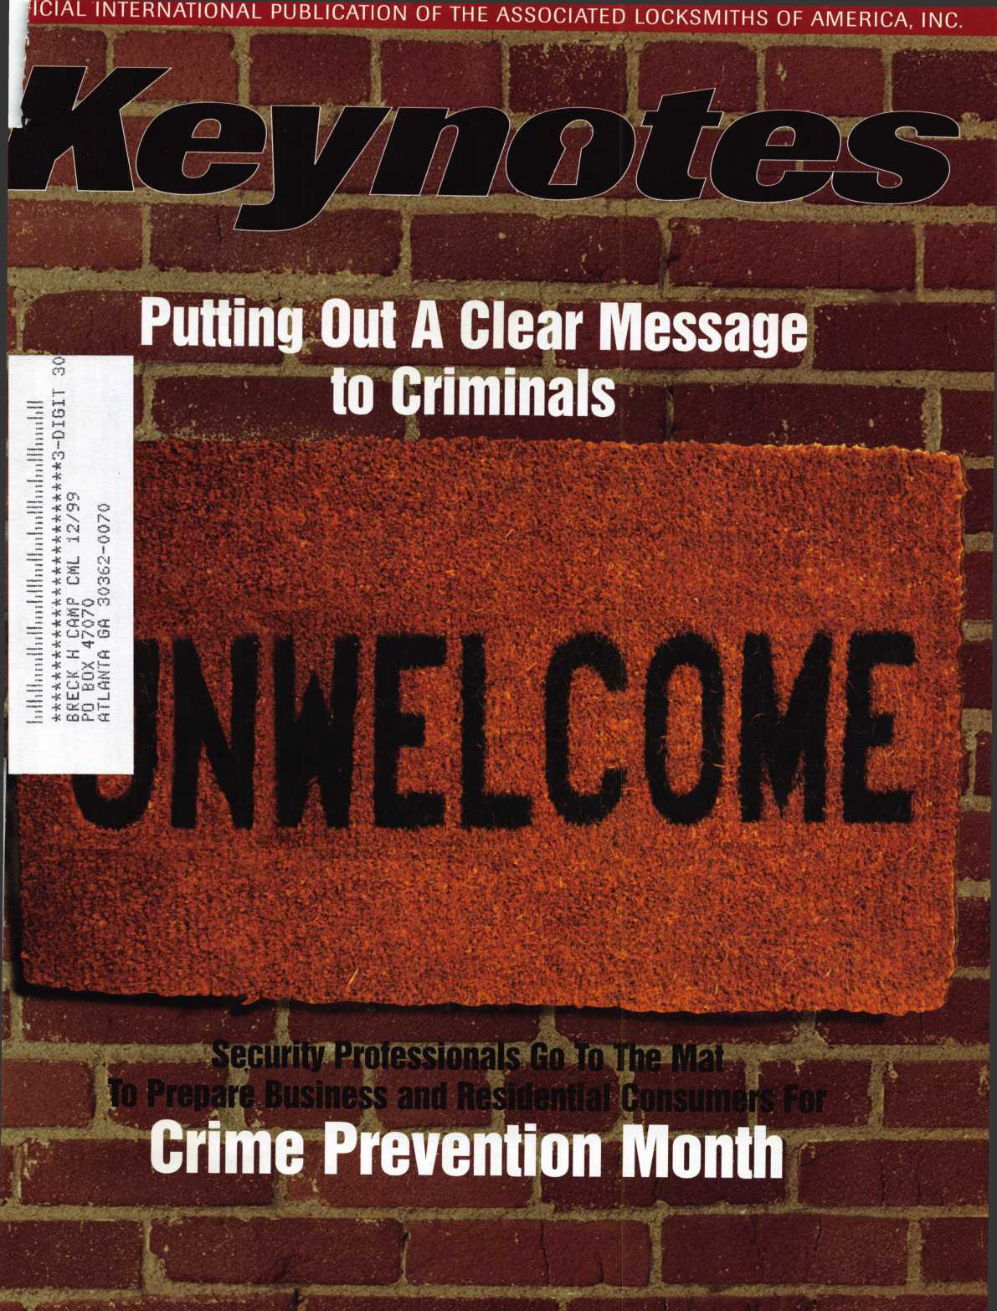

**We're saving space for you**

J;uly 2 4-30  
Las Vegas, NV

[www.aloa.orq](http://www.aloa.orq)



Las Vegas, here we come!

Yes, ALOA ’99 in Cincinnati has come and gone. That means its time to start looking towards the 21st century and ALOA 2000 in Las Vegas.

So, while some people may start lifting weights in preparation for hours of slot machine action, or getting advance tickets to Siegfried and Roy, we decided to pick your brains with a trivia quiz on this famous city.

One lucky winner will be drawn and receive a very special prize! Good Luck!

1. In the late 1980s, the University of Nevada-Las Vegas basketball team ruled the hardwood. Name their coach, who was nicknamed “The Shark.”
2. Some knew Joe Louis as one of the greatest boxers who ever lived.

Others knew him as a guy who greeted visitors at a famous casino.

Name the casino.

1. Last year, a movie detailing a journalists exploration of Las Vegas was released.

It was based on a book of the same title. Name it.

1. Which of these films did not have anything to do with Las Vegas?
2. Mars Attacks
3. Con Air
4. Indecent Proposal
5. Austin Powers
6. Scream

Send Entries to:

Las Vegas Trivia Quiz

3003 Live Oak Dallas, TX 75204 (214) 827-1810 fax

or email to:

keynotes @anet-dfw. com

0 0

|  |  |  |  |  |  |  |
| --- | --- | --- | --- | --- | --- | --- |
| 30OVSA.1 | |  | 0  1 | 300VSA.2 |  | Go ahead, use us - we don’t mind. |
|  | _ °L__J | 1 | i° 1 |  | Here at Security, we’re ready to pro­security technology with exceptional |
|  | |  |  |  |  |

intricate access control systems to electronic locking devices.

01010

***gWW***

In addition, our technical staff is  
ready, willing and able to assist you in  
all aspects of security detailing, from  
hardware specifying to system layout.

Of course, we still offer overnight

delivery, nationwide service centers,

he best catalog in the business, and  
he largest inventory in the country.

) why not take advantage of us?

After all, everyone else does.

LOCK DISTRIBUTORS

THE IN DEPTH DISTRIBUTOR OF  
**LIFE SAFETY AND SECURITY PRODUCTS**

Phone: 1-800-847-5625 • Fax 1-800-878-6400  
e-mail: [info@seclock.com](mailto:info@seclock.com)  
Web: [www.seclock.com](http://www.seclock.com)

BOSTON, MA • POMPANO BEACH, FL • LAS VEGAS, NV

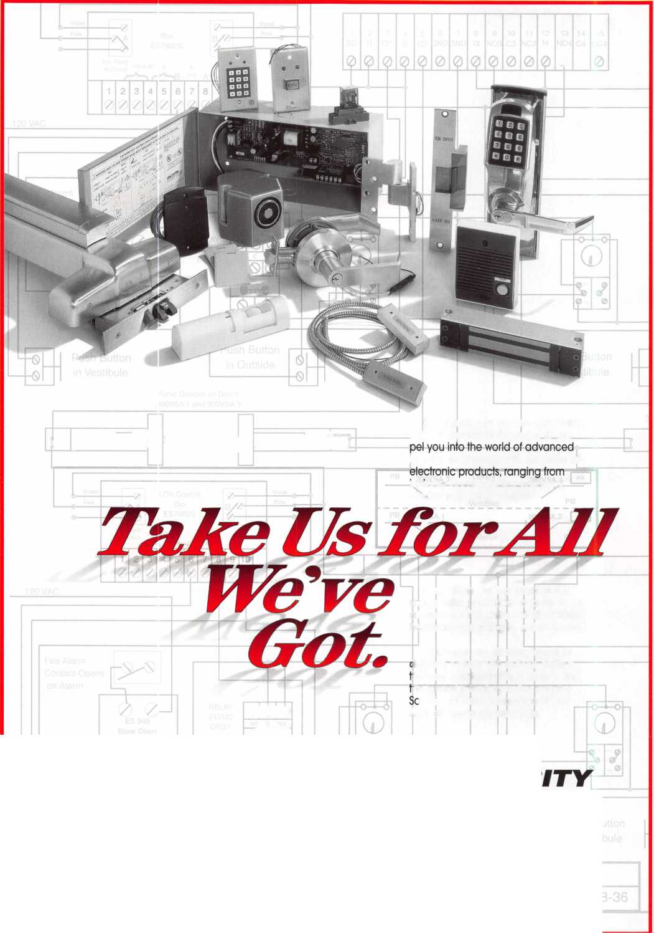

When you neecrwT^PsuiJaJjpnts, yet fast, inexpensive VATS Replacement tucks and keys from BWD Certified VfXfS Centers. Plus, become a Certified

fil/l/D Automotive

Automotive Locks, Keys, Service Kits, Manuals & Training  
for the Professional Locksmith

enters and

Schedule, see offer below.

**FREE!**

1999 Illustrated Automotive Parts Catalog

including BWD Service Manual Library Centers,Distributors,  
VATS Centers, Seminar Schedule, and more... call

(**800**) **647-4926**

or take your web browser to [www.alllock.com](http://www.alllock.com).



Lou-Miss

Locksmith Association

**ANNUAL CONVENTION**

September 30-October 2, 1999 Baton Rouge, LA Holiday Inn East

(504) 293-6880 Hotel Reservations

Classes in Exit Device Servicing & Installation, Automotive Servicing & Installation, Aluminum Storefront Doors and Automotive Opening are

conducted by the ALOA Continuous Education (ACE) instructors. The membership breakfast will be Saturday morning followed by the exhibits opening from 1 1 a.m.-2 p.m. Testing for the Proficiency Registration Program (PRP), will be given Saturday afternoon following the closing of the exhibits at 3:00 p.m. For more information contact the ALOA Education Department at (800) 532-2562.

J Keynotes September 1999

Keynotes

Authors

Dept

Donald B. Dennis, CPL has hem dealing with the Locksmithing profession since 1972 with a four year apprmticeship in Albuquerque, New Mexico. He founded and has hem the owner ofDmnis Safe & Lock in Johnson City, Tmnessee since 1977. He was the founder of the East Tmnessee Locksmith Association in 1988 and is currmtly the Chairman of the Education Committee and editor ofETLA Newsletter.

I Sal Dulcamaro, CML, has hem in the locksmith business for over

24 years. He is the president of All Pro Security, Inc. in Michigan and has hem  
an ALOA member for 17 years. A past president of the Locksmith Security  
Association of Michigan. Sal currmtly serves as editor of the association newsletter.  
He was named “Keynotes Author of the YeaP’ for 1996 and 1997. He is also  
a contributing editor for Keynotes.

Mike Emery is the Editor of Keynotes and a freelance music,

film and real estate writer.

Mike Ferrill is a third generation locksmith, who lives on the

Island of Nantucket in Massachusetts.

Tim McMullm oversees legislative affairs for ALOA. He is a

graduate of the District of Columbia School of Law and has an extmsive  
background in legislative work.

Greg Perry has bem in the locksmith industry for 18 years. He's spmt half that time as a field technician for the Security Engineering in Ridgecrest, Calif. Greg is also a past presidmt of Desert Counties Chapter of the California Locksmiths Association.

George A. Sharpley, CML is a freelance writer for Keynotes and Safe and Vault Technology magazines.

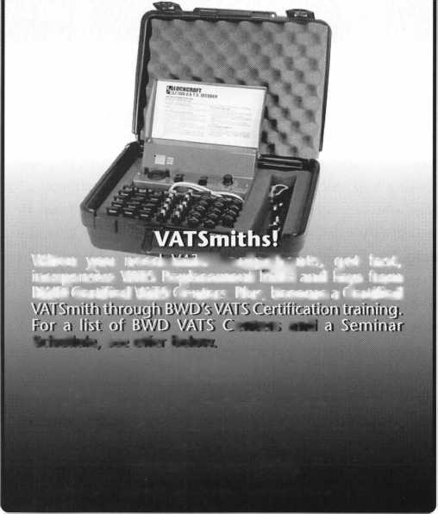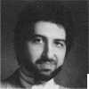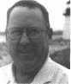

|  |  |  |  |  |
| --- | --- | --- | --- | --- |
| -  1  j  Lemslat | | iveL | Jod | ate |
| Mb | o | | X  by Tim McMullen | |

ALOA CONVENTION A WINNER FOR GOVERNMENT AFFAIRS!

On site lobbying, a historic meeting, sharing ideas and popcorn highlighted this year’s legislative convention activities. At the Legislative Booth, ALOA members faxed the U.S. Postmaster General, asking him to enforce the mail-order lockpick law passed by Congress in 1988. Recent non-enforce­ment by postal inspectors has resulted in more lockpicking devices being sold through the mail, and especially over the Internet. Over 100 letters were sent during the three-day tradeshow. Thanks to all who participated! The booth also gave members a chance to find out what was happening at their state capitol that could effect their businesses. Even better, we had over 50 new people sign up for the Legislative Action Network! And of course, there was the aromatic popcorn given away by a smiling face.

Outgoing ALOA President, Dallas C. Brooks, led the discussion on an idea that had been generating within a number of members for some time. The idea being to come up with a way locksmiths could further unite for the betterment of the industry. With that, Friday afternoon of the Convention saw history being made as the first Presidential Roundtable on Chapters and Regional Associations was held. The two-hour meeting helped everyone understand how other organizations and associations operate. Over 40 people attended the meeting representing ALOA Chapters, as well as state, regional and local associations. In the end, it was agreed that clear-cut communications was the best vehicle for success. The most effective way to this was through a ‘list serve’ coordinated by ALOA as well as a chat room for affiliates to have Internet meetings and exchange ideas. The ‘list serve’ would help coordinate educational classes, legislative issues, trade shows, meetings and other items of interest.

The State of the States Roundtable was another great meeting for exchange of information and ideas. The one-hour session proved to be too short for all the great thoughts everyone had! Again, the attendance was well over 40 people representing ALOA Chapters, as well as state, regional and local associations. It was a wonderful way for groups to share ideas like the mentoring program at the Maryland Locksmith Association, PRP study groups organized through Michigan’s Master Locksmith Association, and even that the Veterans Administra­tion will pay for veterans to learn a new trade. The meeting was also a prime opportunity to let everyone know what was going on in their states with various pieces of legislation or current laws (most people agreed Tennessee had it the worst!).

The Legislative Action Network Reception held

Saturday night, gave everyone an opportunity to relax a bit after

being on the show floor and in meetings all day! It was also a way for ALOA to say, “THANK YOU” to all the Network members for going above and beyond the call of duty, such as traveling 300 miles to the statehouse and giving testimony before a Senate committee. A special presentation was made to the Legislative Action Network’s Organization of the Year, the Texas Locksmith Association. TLA President Patricia Titus accepted the award on behalf of the chapter, who worked long and hard with a lobbyist in getting a harmful law amended (see below). The chapter also received a check for $500.00, which represented all the generous donations received at the legislative booth during the convention.

Overall, this new convention format for ALOA’s Government Affairs department looks to be a real winner. It offers organiza­tions a voice that wasn’t there before, and also a way for locksmiths to share information for the betterment of the industry. See you next year in Las Vegas!

ATTENTION TEXAS LOCKSMITHS!

Governor George W. Bush signed into law House Bill 2617, the legislation dealing with the Board of Private Investigators and Private Security Agencies (which will now be known as the Private Security Commission).

The legislation contained two changes that will help many locksmiths. One change in the law clarifies the definition of “alarm systems company” by specifying that to be classified as such a company it must install devices “used to signal the presence of an emergency to which law enforcement or emergency services are expected to respond.” That provision also strikes out existing law that brought many persons who install access control devices under state regulation. The second change in the law deals with the definition of “detection device.” The change simply strikes the new language added four years ago that had the effect of bringing access control installers under state regulations.

The result is that locksmiths and others who install access control devices that are not part of a monitored system that sends a signal to law enforcement or security personnel will not be subject to any state regulation. The law is now abundantly clear on that front.

Jim Warren TLA Lobbyist

|

September 1999Keynotes | 41

Accept Credit Cards  
and Increase Sales and Profits  
by 30% - 50%

There are three reasons why people don’t accept credit cards:

Through Association Benefits ^ 1. Too expensive.

These Concerns Are Eliminated 2. The paperwork hassle.

3. Inability to qualify.

Here’s how it works:

* Simply swipe or enter the credit card #.
* Enter amount of sale. \« Hassle - Easy Qualifying
* Approval within seconds.
* Funds wired electronically into your local checking account within 48 hours.

Because off your association membership, nearly 100% of all retail and home based applicants

will be approved even with past credit problems.

Currently Processing Merchants Please Read

Monthly Lease To Own Set-Up Options

Special Low Discount Rate and Transaction Fee: 1.59% + 20<t

Plus Monthly Statement/Customer Service Fee: $10

Package A: $29.95 Terminal

Package B: $39.95 Terminal & Printer In One

Deluxe Package C: $49.95 Portable Terminal/Pnnter/Rn Rad Debit acess fee Ability to Accept Visa/MC “Check Cards” $l0/m°. & ATMcards ataFLAT 25

Totally Eliminating the 1.59 % Rate

(All lease terms 48 months • Monthly minimum $25)

J| I authorize Universal’s sales office to print and deposit a check in the amount of $49 (normally $125) for my application fee which covers initial materials, application processing, equipment warranty, shipping & handling, programming, installation and training.

* Fill out a check, tape here above mini form and then fax.

Fax Express Mini Form Now To 1 -800-439-7773

F°r Me

Secei

'n Fee •

Fee

Yo

• rtbllcard

.?Pyour

Pert

^doata^^0OO',>ged.

*^^Pt* every

°fyour

cunent

****«» CB»e««> To

Company Name. Contact Name _

Address. City

State.

Zip-

Phone

Best Time

Signature

New Account Set-up Options (Check)

Package A □

Package B □

Deluxe Package C I—I

Free Pin Pad Program For Currently Processing Merchants □

A subsidiary of Universal Savings Bank, f

Marketing Office 1-800-836-4295

Universal Payment Processing Provides 24 Hour Live Customer Service.

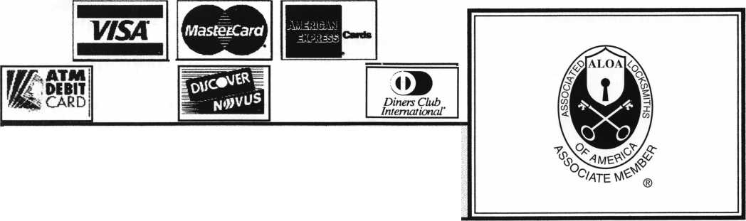

|  |  |
| --- | --- |
| McManus Locksmith Supply, Inc.  P.O. Box 9231,1309 Central Ave.  Charlotte, NC 28299 (702) 333-9112; FAX (704) 332-8664  • ••••• | Top Notch Distributors, Inc.  3151 Goni Rd.  Carson City, NV 89706-7922 (800) 722-4210; FAX (800) 248-3620  • §• |
| McMaster-Carr Supply Company  600 County Line Rd,  Elmhurst, IL 60126-2081  C630) 833-0300; FAX (630) 834-9427  • ••••• | Turn 10  P. O. Box 746  Marietta, OH m45750 (800) 848-9790; FAX (800) 391-4553  • • |
| Monaco Lock Co.  339-345 Newark Ave.  Jersey City, NJ 07302 (800) 526-6094; FAX (800) 845-LOCK  • • • | U.S. Lock Corporation  77 Rodeo Drive  Brentwood, NY 11717 (800) 925-5000; FAX (800) 338-5625  • • • • • |
| Securite.com  4775 Viewridge Avenue  San Diego, CA 92123 (800) 241-3930; FAX (619) 974-5269  • • • | Webster Safe & Lock Company, Inc.  3020 Millbranch  Memphis, TN 38116 (901) 332-2911; FAX (901) 332-2878  ••••••• |
| Omaha Wholesale Hardware  1201 Pacific Street PO Box 3628  Omaha, NE 68108 (800) 238-4566  •••••••• | Service |
| Security Lock Distributors  40 A Street  Needham Heights, MA 02194 (800) 847-5625; FAX (800) 878-6400  • • • | Alarm Monitoring Service, Inc.  5021 Fairfield St  Metairie, LA 70006 (504) 454-2163; (504) 456-8737  • |
| Sentry Security Fasteners  8109 N. University  Peoria, IL 61615  (309) 693-2800; FAX (309) 693-2872  • • | Allstate Insurance Company  2775 Sanders Road, Suite A5  Northbrook, IL 60062 (847) 402-8196; FAX(847) 326-7509  • |
| Southern Lock and Supply Co.  Box 1980,10910 Endeavor Way  Pinellas Park, FL 33780 (800) 237-2875; FAX: (800) 447-2299  ••••••••• | Diamond Software  2952 N. Expressway  Griffin, GA 30223  (770) 227-7650; FAX (770) 227-1699  • |
| Stone & Berg Wholesale  99 Stafford Street  Worcester, MA 01603 (800) 225-7405; FAX (800) 535-5625 | Locksmith Publishing Corp.  850 Busse Hwy.  Park Ridge, IL 60068 (847) 692-5940; FAX (847)692-4604  • |
| Strauss Safe & Lock Company  1801 Second Avenue  Des Moines, IA 50314 (515)288-9571; FAX: (515)288-9752  ^ ^ ^ n § | The National Locksmith Magazine  1533 Burgundy Parkway  Streamwood, IL 60107 (630) 837-2044; FAX (630) 837-1210  • |
| Timemaster, Inc.  127 SE 29th Street  Topeka, KS 66605  (785) 232-8705; FAX (800) 798-8463  (0) (0 ($ ^ | Pine Technical College  1000 4th Street  Pine City, MN 55063 (800)521-7463; FAX (320) 629-7603  • |
|  |  |

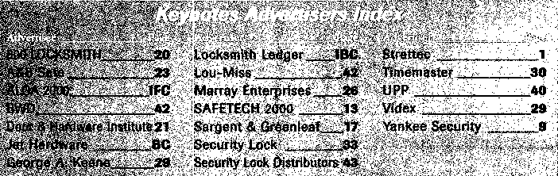

It pays

to have new faces  
in the crowd.



During 1999  
each ALOA member  
who sponsors  
a new applicant  
will receive $40 in  
Convention Bucks  
(upon clearance,  
and payment of  
application fee and dues).

September 1999

***Keynotes* 139**

|  |  |  |
| --- | --- | --- |
| Wilson Bohannan Company  621 Buckeye Street  Marion, OH 43301-0504 (800) 382-3639; FAX (740) 383-1653  • | Cook’s Building Specialties  2441 Menaul Blvd. NE; P.O. Box 37320 Albuquerque, NM 87176-7320 (505)883-5701; FAX (505) 883-5704  •••••• | Hans Johnsen Company  8901 Chancellor Row  Dallas, IX 75247  (214) 879-1550; FAX (214) 879-1530  •••••••• |
| Yale Security Inc.  P.O. Box 25288  Charlotte, NC 28229-8010 (800) 438-1951; FAX (800) 338-0965  • • • • | DiMark International  3117 Liberator St, Unit A  Santa Maria, CA 93455 (800) 235-2435; FAX (805) 928-8034  • • • • • | Hardware Agencies, Ltd.  1220 Dundas Street East  Toronto, ON M4M 1S3 (416) 462-1921; FAX (414) 462-1922  •••••••• |
| Zhongshan Hua Feng Lock Products  S Yongning Industrial Road, Ziaolan Zhongshan Guangdong, China  86-760 227 82 63; FAX 86-270 227 80 63  • | Dire’s Lock & Key Co.  2201 Broadway  Denver, CO 80205  (303) 294-0176; FAX (303) 294-0198  ••••••••••• | Hardware Suppliers of America  P.O. Box 2208  Winterville, NC 28590 (800) 334-5625; FAX (800) 334-5635  • • |
| [BistFitatoffs | Direct Security Supply, Inc.  36 Lincoln Street  Boston, MA 02135 (800) 252-5757; FAX (800) 452-8600  ••••••• | IDN, Inc.  1000 S. Main, Suite 280  Grapevine, TX 76051 (817)421-5470; FAX (817) 421-5468  •••••••••• |
| Accredited Lock Supply Co.  P.O. Box 1442  Secaucus, NJ 07096-1442 (800) 652-2835; FAX (201) 865-5031  ••••••• | Doyle Lock Supply  2211 W. River Road N.  Minneapolis, MN 55411 (800) 333-6953; FAX (612) 521-0166  ••••••••••• | Intermountain Lock & Supply Co  3106 South Main Street  Salt Lake City, Utah 84115 (800) 453-5386; FAX (801) 485-7205  •••••••••• |
| Ace Lock & Security Supply Co.  565 Rahway Ave.  Union, NJ 07083-6631 (800) ACE-LOCK; (800) ACE-FAX4  •••••••• | Dugmore & Duncan Inc.  30 Pond Park Rd.  Hingham, MA 02043 (888) 384-6673; FAX (888) 329-3846  ••••••• | JLM Wholesale, Inc.  3095 Mullins Ct  Oxford, Ml 48371-1643 (800) 522-2940; FAX (800) 782-1160  • • • |
| ADI  263 Old Country Road  Melville, NY 11747 (516) 692-1000; FAX (516) 692-3457  • M | E. L. Reinhardt Co., Inc.  3250 Fanum Road  Vadnais Heights, MN 55110 (800) 328-1311; FAX (612) 481-0166  •••••• | Jo-Van Distributors Inc.  929 Warden Ave.  Scarborough, Ontario MIL 4C6 (416) 752-7249; FAX (416) 752-3845  ••••••••••• |
| Akron Hardware Consultants, Inc.  2579 South Arlington Road  Akron, OH 44319  (800) 321-9602; FAX (800) 328-6070  • • • | Ewert Wholesale Hardware  4709 W 120th St  Alsip II 60658  (800) 451-0200; FAX (708) 597-0881  • • • • • | Lockmasters, Inc.  5085 Danville Road  Nicholasville KY, 40356 (800) 654-0637; FAX (606) 885-7093  • • • • |
| American Security Distribution  4411 E. La Palma  Anaheim, CA 92807 (714)996-0791; FAX (714) 579-3508  ••••••• | Fairway Supply, Inc.  2631 Lombardy Lane  Dallas, TX 75220  (214)350-0021; FAX (214) 352-4299  ••••••• | Locks Company  2050 N.E. 151 St  N. Miami, FL 33162 (800)288-0801; FAX (305) 949-3619  ••••••• |
| Andrews Wholesale Lock Supply  544 S. 9th St.  Lebanon, PA 17042-6608 (717) 272-7422; FAX (717) 274-8679  • | Foley-Belsaw Company  6301 Equitable Road  Kansas City, MO 64120 (800)821-3452; FAX (816) 483-5010  • ••• | The Locksmith Store Inc.  1229 E Algonquin Rd. Suite E  Arlington Heights, IL 60005 (847) 364-5111; FAX (847) 364-5125  • • • • |
| Boyle & Chase Inc.  P. 0. Box 74  Accord, MA 02018-0074 (800) 325-2530; FAX (800) 205-3500  • • • | Fried Brothers, Inc.  467 N. 7th St.  Philadelphia, PA 19123 (800) 523-2924; FAX (800) 541-3489  •••••••••• | M. Zion Company  69 Reade Street 4th Floor  New York, NY 10007 (212) 349-8677; FAX (212) 964-0495  ••••••• |
| Clark Security Products, Inc.  4775 Viewridge Ave.  San Diego, CA 92123-1641 (800) 854-2088; FAX (619) 974-5284  •••••••••• | HS&S Wholesale Distributors  12915 West 8 Mile Road  Detroit Ml 48235  (800) 521-2202; FAX (313) 342-7580  ••••••• | McDonald-DASH Locksmith Supply  5767 E. Shelby Dr.  Memphis, TN 38141 (800) 238-7541; FAX (901) 366-0005  •••••••• |
|  |  |  |
| ® Alarms 9 Business/Tech & Ed. 9 Tools & Supplies  9 Bank Security Equipment 9 CCTV/Photo Imaging 9 Safes/Vaults  9 Automotive 9 Electric/Electronic Security 9 Other  9 Builders Hardware 9 Lock Devices | | |

**38|** Keynotes

September 1999

|  |  |  |
| --- | --- | --- |
| Fort Lock Corp.  3000 N. River Rd.  River Grove, IL 60171 (708) 456-1100; FAX (708) 456-9476 | La Gard, Inc.  3330 Kashiwa Street  Torrance, CA 90505 (310) 325-5670; FAX (310)325-5615 | Sargent & Greenleaf, Inc.  P.O. Box 930  Nicholasville, KY 40340-0930 (606) 885-9411; FAX (606) 887-2057 |
| • ••••• | see | 9 9 ® 9 |
| Grobet File Co. of America  750 Washington Ave.  Carlstadt, NJ 07072 (800) 962-7242; FAX (800) 243-2432 | Lucky Line Products  7890 Dunbrook Rd.  San Diego, CA 92126 (619) 549-6699; FAX (619) 549-0949 | Schlage Lock Co.  1915 Jamboree Suite 165  Colorado Springs, CO 80920 (800) 847-1864; FAX (800) 452-0663 |
| • | • | 9 9 |
| H.E.S., Inc.  2040 W. Quail Ave.  Phoenix, AZ 85027 (602) 582-4626; FAX (602) 582-4641 | M.A.G. Engineering & Mfg. Inc.  15261 Transistor Lane  Huntington Beach, CA 92649 (714) 891-5100; FAX (714) 892-6845 | Schwab Corporation  110 Professional Court  Lafayette, IN 47905 (765) 447-9470; FAX (765) 447-8278 |
| (0 (j£) | • • • | • |
| HPC, Inc.  3999 N. 25th Avenue  Schiller Park, IL 60176 (847) 671-6280; FAX (847) 671-6343 | MARKS USA  5300 New Horizons Blvd.  Amityville, NY 11701 (516) 225-5400; FAX (516) 225-6136 | Securitron Magnalock Corp.  550 Vista Blvd.  Sparks, NV 89434  (800) 624-5625; FAX (702) 355-5636 |
| • • • | • | 9 9 |
| HID Corporation  9292 Jeronimo Road  Irvine, CA 92618  (949) 568-1600; FAX (949) 568-1680 | MUL-T-LOCK USA, Inc.  300-1 Route 17 South Suite A  Lodi, NJ 07644  (800) 562-3511; FAX (973) 778-4007 | Security Door Controls  3580 Willow Lane  Westlake Village, CA 91361 (805) 494-0622; FAX (800) 959-4732 |
| <0 • | • • • | <0 |
| llco Unican  400 Jeffreys Road  Rocky Mount NC 27804 (252) 446-3321; FAX (252) 446-4702 | Master Lock Company  2600 North 32nd Street  Milwaukee, Wl 53211 (414) 444-2800; FAX (414) 449-3114 | Security Solutions  1640 W. Hwy. 152  Mustang, OK 73064 (405) 376-1600; FAX (405) 376-6870 |
| ••••••• | 9 9 | OS® |
| In Out Systems, Inc.  3650-B Matte Boulevard  Brassard, Quebec J4Y-2Z2, Canada (450) 444-5949; FAX (450) 444-4856 | Medeco Security Locks  P.O. Box 3075  Salem, VA 24153  (540)380-5000; FAX (540) 380-5010 | Sentry Group  900 Linden Ave.  Rochester, NY 14625-2784 (716) 381-4900; FAX (716) 381-8559 |
| • • | • • • | • |
| Intellikey  551 S. Apolo Boulevard, Suite 204  Melbourne, Florida 32901 (800) 226-0703; FAX (407) 724-0811 | Meilink Safe Company  111 Security Parkway  New Albany, IN 47150 (800) 634-5465; FAX (800) 896-6606 | Sully Tools Inc.  3515 Nodding Pine Ct.  Fairfax, VA 22033  (703) 689-3416; FAX (703) 787-0869 |
|  | • | 9 9 9 |
| KABA High Security Locks  P.O. Box 490  Southington, CT 06489 (860) 621-3601; FAX (860) 621-9727 | National Cabinet Lock  200 Old Mill Road, P. 0. Box 200  Mauldin, SC 29662 (864) 297-6655; FAX (864) 297-9987 | Taymor Industries, Inc.  1586 Zephyr Ave.  Hayward, CA 94544 (800) 388-9887; FAX (800) 288-8133 |
| • | 9 | • • |
| KEY-BAK; Div. of W. Coast Chain Mfg. Co.  1460 S. Balboa Ave.  Ontario, CA 91762 (909) 923-7800; FAX (909) 923-0024 | Newman Tonks  805 N Buckman St.  Shepardsville, KY 40165 (800) 826-5792; FAX (800) 777-8229 | Trine Products Corporation  1430 Ferris Place  Bronx, NY 10461  (718) 829-4796; FAX (718) 792-9127 |
| • • • • | • 9 | 9 9 9 |
| Knaack Manufacturing Co.  420 E. Terra Cotta Ave.  Crystal Lake, IL 60014 (800) 456-7865; FAX (815) 459-9097 | ROFU International Corp.  2004-B 48th Ave.; Court E  Tacoma, WA 98424 (800) 255-7638; FAX (253) 922-1728 | Videx, Inc.  1105 NE Circle Blvd.  Corvallis, OR 97330 (541) 758-0521; FAX (541) 752-5285 |
| • | 9 9 9 | 9 9 9 |
| LAB Security  700 Emmett St.  Bristol, CT 06010  (800) 243-8242; FAX (203) 583-7838 | Rutherford Controls Inc.  2697 International Pkwy, Bid 5 #100  Virginia Beach, VA 23452 (757) 427-1230; FAX (757) 427-9549 | W-Lok Corporation  675 East 16th Street, Suite 111  Holland, Ml 49423 (616) 355-4015; FAX (616) 355-4295 |
| • | • | ® |
| LCN Closers (Division of Ingersol)  121 W. Railroad Ave.  Princeton, IL 61356 (815) 875-3311; FAX (815) 875-3222 | STRATTEC Security Corp.  3333 W. Good Hope Rd.  Milwaukee, Wl 53209 (414) 247-3333; FAX (414) 247-3329 | Weiser Lock Company  6700 Weiser Lock Blvd.  Tucson, AZ 85746  (502) 741-6338; FAX (520) 741-6363 |
| m | 9 ® 9 | • • |
|  |  |  |

September 1999

***Keynotes***

37

**Associate**

Members



|  |  |
| --- | --- |
| Manufacturers | Arrow Lock Company  10300 Foster Avenue  Brooklyn, NY 11236 (718) 257-4700; FAX (718) 649-9097 |
|  | • • • • |
| A & B Safe Corp.  171 S. Delsea Dr.  Glassboro, NJ 08028 (800) 253-1267; FAX (609) 863-1208 | Auto Security Products (A. S. P.)  P.0. Box 10  Redmond, WA 98073-0010 (425) 556-1900; FAX (425) 558-1205 |
| • • • • | • • |
| ASSA Inc.  10300 Foster Ave.  Brooklyn, NY 11236 (800) 235-7482; FAX (718) 257-2772 | BWD Automotive  900 Raven wood Dr.  Selma, AL 36701  (334) 874-9001; FAX (334) 874-6011 |
| • | • • |
| Abus Lock Company  3555 Holly Lane North  Plymouth, MN 55447-0507 (800) 352-2287; FAX (612) 509-9939 | Chicago Lock Company  10100 88th Ave.  Pleasant Prairie, Wl 53158-0069 (800) 445-3204; FAX (414) 947-7178 |
| • | • |
| Adams Rite Manufacturing Co.  P.0. Box 1301  LaPuente,CA 91749-1301 (562) 699-0511; FAX (562) 699-5094 | Corbin Russwin Architectural Hardware  P.0. Box 25288  Charlotte, NC 28229 (800) 543-3658; FAX (800) 447-6714 |
| • • • • | • • • • |
| Adesco Safe Manufacturing Co.  web: [www.adesco.com](http://www.adesco.com) email: [sales@adesco.com](mailto:sales@adesco.com) (800) 821-6803; FAX (562) 408-6427 | Curtis Industries  6140 Parkland Blvd, Ste. 300  Mayfield Heights, OH 44124-4103 (800) 555-5397 |
| • | • • |
| Adrian Steel Company  web: [www.adriansteel.com](http://www.adriansteel.com)  Adrian, Ml 49221  (800) 677-2726; FAX (517) 265-5834 | DETEX  302 Detex Dr.  New Braunfels, IX 78130 (800) 729-3839; FAX (830) 620-6711 |
| • | • • • • |
| Alarm Lock Systems, Inc.  345 Bayview Ave.  Amityville, NY 11701 (800) ALA-LOCK; (516) 789-3383 | Don-Jo Manufacturing, Inc.  P.0. Box 929  Sterling, MA 01564 (508)422-3377; FAX (508) 422-3467 |
| • | e ® |
| Aiphone Intercom Systems  1700-130th Avenue, NE  Bellevue, WA 98005 (425) 455-0510; FAX (425) 455-0071 | Door Controls International  2362 Bishop Circle East  Dexter, Ml 48130  (800)742-3634; FAX (800) 742-0410 |
| see | • • • • |
| American Lock Co.  3400 West Exchange Road  Crete, IL 60417-2099 (708) 534-2000; FAX (708) 534-0531 | ESP Lock Products, Inc.  375 Harvard Street  Leominster, MA 01453 (978)537-6121; FAX (978) 534-9109 |
| • f | m e |
| American Security Products (AMSEC)  11925 Pacific Ave.  Fontana, CA 92337-6963 (800) 423-1881; FAX (909)685-9685 | Folger Adam Security, Inc.  16300 W. 103rd Street  Lemont, IL 60439  (630) 739-3900; FAX (630) 739-6138 |
| • • | • • |
|  |  |

Associate members of the Associated Locksmiths of America (ALOA) manufacture or distribute materials or equipment, or provide services, for the security industry. Many have donated money, services and equipment to ALOA in addition to their annual dues. Their support of ALOA projects enhances overall membership benefits and we encourage our members to patronize these firms. If you know of a potential candidate for associate membership, please contact the ALOA Membership staff at (800) 532-ALOA. Associate member dues are $500 per year and entitle the payor to use the ALO A logo, and selected discounts on ALOA products and services.

Legend

Personal, vehicle, electronic, fire, burglar, and exit

9 Automotive: Lockout equipment, key chains/rings

9 Builders Hardware: Door closers, furniture/decorative hardware, viewers, emergency exit devices

Books, reference guides, publications, computer software

9 CCTlf/Photo Imaging: Cameras, monitors, photo ID equipment, cables

9 Electric/Electronic Security: Card access control and readers, surveil­lance, electric/magnetic locks and strikes, keypads

9 Lock Devices: Auto locks, cylinders, emergency exit/entrance control, locks (various types), strikes

9 Tools & Supplies: Key blanks, cutters, picks, rlngs/hooks, custom van/truck supplies

9 Other

Keynotes

September 1999

Locksmith Needed

6/F/3: Immediate openings, Outside Technicians and Inside Technicians in Oxnard, Calif. Benefits plus salary, close to the beach, excellent weather. Fax resume to:

Nasons’s Leek & Safe Inc.

(805) 487-8280fax

Salesperson Needed

6/F/3: Wholesale Distributor Seeking Inside Salesperson for its Dallas, Texas Distribution Center. Full Benefits including 40IK Retirement Plan. Send resume to:

Accountants Office 6517 Hillcrest, Suite#308 Dallas, TX 75205

Lock/Safe Technician

6/F/3: Canadas national safe and lock company requires a Service Technician. Located in Calgary, Alberta, Canada, you will provide service and maintenance to our clients’ physical security equipment. Experience with safes and/or locks is advantageous, but we are willing to invest in the training of a suitable candidate with mechanical ability and/ or aptitude. We offer a competitive salary and benefits package. Please mail or fax your resume to:

John Haining-Regional Manager Chubb Lock & Safe **#8,** 5 708-1st Street SE Calgary, AB T2H 2W9 Canada (403) 255-2222

(403) 258-1702fax

Experienced Technicians Wanted

6/F/3: Family owned business since 1911, serving Knoxville and surrounding areas in East Tennessee are in need of experienced commercial, industrial and residential technicians. Must supply background check, work and personal references. Must have

a clean driving record, no felonies, able to be a team player, neat, honest and good communi­cation skills. Monday through Friday 8 a.m. to 5 p.m. Guaranteed salaries with monthly and yearly bonuses. Insurance and prescription cards for employee and family, retirement after 90-day trial, paid vacation and sick pay after one year. Salary is negotiable. Send resume and cover letter to: **William M. Peters Jr., CRL The EM. George Safe & Lock Company Inc.**

P.0. Box 3398 Knoxville, TN37927-3398

Experienced Locksmith Looking For Position

6/F/3: Downsizing is taking its toll. Locksmith with 20 years of experience is looking for a position in the Dallas/Ft. Worth area. I am experienced in Commercial, Retail, Residential and Corporate locksmithing. I have certification in ASSA, VonDuprin Schlage and many other high security systems. Other experience includes Safe work, stand alone access control systems, masterkeying, lockshop management, purchasing and inventory. I have a lot to offer. Looking for a company I can retire with. I prefer to stay in the Dallas/Ft.Worth area, but relocation is negotiable. If interested, direct all inquiries to:

Keynotes Classifieds 3003 Live Oak Street Dallas, TX 75204 (214)827-1701 (214) 827-1810fax

M BUSINESSES FOR SALE Business For Sale

9/F/3: A well established, 18 years, locksmith business on a major road in Baltimore County, Maryland is for sale. Customer base includes commercial, government, automotive, auto dealers, residential and walk-in trade. Main building has a retail area, workshop area, office space and storage area on second floor. Garage building has a two bay service area. Excellent growth potential for aggressive owner. Last years gross sales were $217,000. Asking $198,000. **Inquire for a list of equipment included.**

Locksmith

PO Box 19018

Baltimore, MD 21284-9018

Locksmith Shop For Sale

9/F/3: Full service locksmith shop in Southern California serving the Beaumont/Banning area for over 26 years is for sale. Includes equipment, inventory, commercial accounts and a 1984 1/2 ton Ford van. 1800 sq. feet building also available for lease or sale. Owner can stay on for transition. **Call weekdays for details or leave message:**

(909) 845-5397

Business For Sale

7/F/3: Northern New Jersey locksmith business for sale. Concentration on Corporate and Commercial with less emphasis on retail. Three fully equipped mobile shops, inventory and equipment included in sale. Located in affluent residential town near heart of Corporate community.

Contact: Michael Ryan (973) 599-9302

Business For Sale

6/F/3: Well established business mostly commercial and government accounts, plus residential and automotive. Located in a growing community in northeast Dakota. Gross 118K, price includes inventory, tools computerized codes and MasterKey systems. 95 Ford Aerostar Van, fully equipped. Owner planning to relocate. Call: **(701) 775-6993**

Business For Sale

7/F/3: Complete Locksmith Business with a 1996 GMC Safari Van fully equipped. Located between Phoenix and Tucson in Casa Grande, Ariz. Shop is in the busy downtown area with lots of walk-in traffic plus over 200 established accounts-include commercial, industrial, retail, city, county, Indian reservations and residential. All phases of locksmithing including automotive and safe sales and service. Well established family business since 1969 with reputation of excellence in our community. Perfect family business for honest, dependable locksmiths. Last 3 years net over $200K. Owners moving, but will stay on for transition period. Asking $180K-terms negotiable.

Call:

Carol Walker (888) 229-2464, or Milton and Florence Thompson (520) 836-7662

Master Locksmith Business For Sale

9/P/3: Located in East Yorkshire, England. Established for 20 years. Excellent financial track record with a large number of regular and consistent customers. Showroom, workshop, offices and trained MLA locksmiths. Available due to early retirement reasons only. Send all inquiries to:

Gamess Jones 732A Anlaby Road Hull

HU4 6BP England

■ WANTED TO BUY/SELL Wanted To Sell

9/F/3: Retired locksmith has several items for sale. Miles Osborne Safe $40. Lockmasters Cutaway Lock For Manipulation, all metal mount $40. Back issues of Locksmith Ledger and National Locksmith and other items for list. **Locksmith**

45055 East Florida **#8** Hemet, CA 92544

Sets For Sale

9/F/3: LTI Rocker pick sets, LT340A Auto set and LT 280 GM set. Never used with instructions.

$75 for both, includes shipping.

CallJohn:

(203) 397-3093

Misc. Items for Sale

6/F/3: 457 Magnum with magnets and case, various older safe locks, wheel packs nests, 3-wheel, 4-wheel, 5-wheel, OB2, Emperor,

HHH, Debrid, etc. Old Safe Deposit Locks-3300, 3311, etc. 30 Lock nest with keys. Will trade all or part. Call for prices:

Dan Blackwood (208) 847-1999

HPC Code Punch Machine For Sale

6/F/3: HPC Code Punch Machine with Punches: PCH 1011, PCH 1014 and PCH 14. Accessories include: 79 code card/ 4 micro-meter cards, HPC Depth and Spacing book, Allen Wrench, Punch Die Wrench, Depth Adjustment Wrench, Manual and Carrying Case. $750 OBO. Serious Inquiries Only. **Contact:**

13610 Langtree Lane Woodbridge, **VA** 22193 (703) 897-0360

Locksmith Tools and More For Sale

9/P/2: Locksmith tools, supplies, machines, two Curtis Automotive Code Cutters, Code books and safe tools. Depth key sets and over 5,000 automotive and domestic keys. $18,500 firm. **Contact:**

John M. Merry P.0. Box 728 Dereby, NY 14047-0728 (716) 549-5439

September 1999

***Keynotes* 1**35

A

**Keynotes**

Classified



Dept

Classified Advertising Policy

**Classified advertising space is provided free of charge to ALOA members, and for a  
fee of $.60 per word, $15 minimum for non-members. Classified ads may be used  
to advertise used merchandise and overstocked items for sale, “wanted to buy”  
items, business opportunities, employment opportunities/positions wanted and the  
like. Members or non-members wishing to advertise services or new merchandise  
for sale may purchase a “Commercial Classified Ad,” for a fee of $1.30 per word,  
with a minimum of $40. Each ad will run for two issues. For blind boxes there is a  
$5 charge to members and non-members. All ads must be submitted in writing to  
the ALOA office by the fifteenth of the month, two months prior to issue date. Send  
to Keynotes Classifieds, 3003 Live Oak St., Dallas TX 75204-6186. ALOA reserves  
the right to refuse any classified advertisement that it deems inappropriate  
according to the stated purpose of the classified advertising section.**

■ EMPLOYMENT Experienced Locksmith Wanted

9/F/3: Large Lock Shop in the Palm Springs area is looking for an experienced locksmith for field work. Must be proficient in Master Keying, safety deposit boxes and working knowledge of safes. Salary plus commission, health insurance benefits and 40IK plan. Please fax resume to:

(760) 779-1811 or Call (760) 346-5214)

Locksmith Superintindent Wanted

9/F/3: The University of California, Los Angeles is in search of a Locksmith Superintindent. The person will assume full managerial and admini­strative responsibility for the Hardware Shop, Fire Extinguisher Shop and Tool Crib. The individual must also possess the ability to implement state of the art keying systems.

Send resume to:

Ron Guizado

UCLA Campus Human Resources rguizado@chr. ucla. edu (310) 206-1010fax

Experienced Locksmiths Wanted

9/F/3: A family owned business since 1959 is looking for experienced locksmiths. Must be self starters. Will pay portion of relocation. Benefits include-Medical Insurance, two weeks paid vacations, annual sick pay, IRA retirement plan, excellent wages plus commission.

Send resume to:

Gene Holder

Holder’s Security Company 7027 E. 40 Th. Street Tulsa, OK 74145 (918) 6663-8660

Security Locksmiths Wanted

9/F/3: If you are a professional Security Locksmith (CML, CPL, CRL, RL), and desire to team up with the best, then JOIN US for a most rewarding career. Our full service commercial security services include Locks, Keys, Safes, Alarms, CCTV and Access Controls. We also provide some residential and automotive work. Ace Lock-Las Vegas is a solid company with an excellent compensation and benefits package for all our team members. Constant training, cross training and upgrading in all skills generates high income and a solid future.

Send or fax resume to:

Harold Ford Ace Lock & Key 1201 S. Casino Center Las Vegas, NV 89104 (702) 382-1754 (702) 382-3963 fax

A Keynotes September 1999

Qualified Apprentice Needed

9/F/3: If you have some training as a locksmith and are willing to work hard and learn fast; and if you desire to team up with the best, then a rewarding career awaits you. We are a full service commercial security service (Locks, Keys, Safes, Alarms, CCTV and Access Controls), over 30 years in Las Vegas. We offer our full time employees an excellent compensation and benefits package, including retirement plan. Under constant training, cross training and upgrading in all skills, high incomes are common and a solid future assured. A drug test and a criminal background investigation will be required. Initial training begins in the shop, assisting a team of professionals and learning all areas of general locksmithing.

Send or fax resume to:

Harold Ford Ace Lock & Key 1201 S. Casino Center Las Vegas, NV 89104 (702) 382-3963 fax

Locksmiths Wanted

9/F/3: Two locksmiths wanted to fill positions in Missoula, Mont. We need an outside and an inside service representative. We have two vans and a storefront. Prefer two years of experience and must be willing to relocate. Salary DOE plus commission possible, paid vacation and the opportunity for advancement.

Call Peter:

(406) 542-2472 (406) 542-3221 fax

Experienced Service Technician Wanted

9/F/2: Experienced Service Technician sought in established company in central Illinois. Must be neat in appearance with good work habits. Good driving record a must. Our company offers a good salary with an excellent benefit package- many Extras.

Send resume or contact:

Denny, Dave & Harry Locksmiths Inc.

116 E. University Ave.

Champaign, 1161820 (217) 352-5034 (217) 352-3505 fax

Senior Account Manager Wanted

9/F/3: A leading company in the high security locks industry is looking for a professional sales manager with strong organization skills to fill a senior account manager position in the Los Angeles area, must have five years experience in the locksmith industry.

Please call Ron (evenings):

(310) 260-9760

Inside Sales Representative Wanted

9/F/3: Jo-Van Distributors Inc., a leading regional distributor of locksmith supplies and security hardware located in Toronto, has openings for inside sales personnel. Prerequisites include excellent organization and communication skills and trade related experience.

(416) 752-7282 fax

Looking For A Position

9/F/3: Institutional locksmith looking for a position. CML, in Northeast area, 22 years institutional and commercial experience, networking for career opportunity with manufacturer, distributor or institutional position. Strong teaching and technical skills. Willing to relocate for the right opportunity. Resume furnished on request.

Call: (800) 532-2562 (214) 827-1810fax

Locksmith Position Wanted

9/F/3:1 am a locksmith with 11 years of experience who recently relocated to the Salem, Ore. area and I am looking for a locksmith position. I am an expert at safe-opening and I own all of my tools. For the last 11 years I worked for VSR Inc in Las Vegas; and I was the manager for the last three. I am ready to work when the opportunity presents itself.

Please call Bryan:

(503) 364-5135

Locksmith Wanted

7/F/3: Large Lock Shop in the Palm Springs area of California is looking for an experienced locksmith for field work. Must be proficient in master keying, safety deposit boxes and working knowledge of safes. Salary plus commission, health insurance benefits and a 40IK plan.

Please fax resume to:

(760) 779-1811 or call (760) 346-5214.

Locksmiths Wanted

7/F/3: The Los Angeles Unified School District is looking for locksmiths. Industrial/institutional locksmithing skills are essential. The ability to design multi-level master key systems is a must. This is a full-time job with a beginning salary of $21.43 per hour. There are some “A” shift openings; but most of the openings are “B” shift positions with working hours from 2 p.m. to 10:30 p.m. In addition to the regular wages, “B” shift employees also earn a 5 1/2% differential.

The District offers an excellent benefit program. It will pay the entire premium for you and your family for your choice of several medical and hospital plans, a dental care plan, a vision plan and a $20,000 life insurance policy. New employees earn two weeks of paid vacation each year, are granted an illness leave bank consisting of 13 days at full pay each year, 87 half days and receive full pay for 12 holidays. If you would like to be automatically sent an application when the filing period opens, please call:

Recruitment Office (213) 743-3551

key machine is used for cutting what keys, and how to maintain and adjust the machines for an accurately cut key. It is not always the machine that is at fault, it could be chips in the vise or the blank not being inserted correctly. If a manual machine is used, the amount of pressure applied will make a difference in the duplicate, and a dull cutter will only make things worse.

ALOA has published a glossary of locksmith terms that should be studied and used so everyone involved knows what is being talked about. Different areas of the country, and different facets of the locksmithing industry use their own words or meaning for the same things.

The trainee should be taught and shown the different grades and classes of locks, what they are used for and how to identify different parts when the lock is not complete. They should know the different finishes and how to identify the finish to match what they need.

They should be able to identify mortise, cylindrical, tubular and rim locks are and how each function. They should also know there are the rim, mortise, and KNB cylinders; how they are constmcted; and the durability of the materials used in their construction. Some materials will take heavy hard usage while others will wear extremely fast.

The trainee should be taught the correct procedure to take a lock apart to be rekeyed and the correct process of pinning the cylinder to get the desired results. They should learn the keying codes used on the keys of large systems and that if they rekey a lock from a large system without the keying charts, they can create all kinds of problems for the owner of the system and themselves.

Trouble shooting a problem lock is very difficult if the person does not know how the lock was made or if it was not installed correctly. The trainee can be taught quite a bit about trouble shooting with a lock that you have doctored up and installed on a display mount. This is also a good procedure to use for the different ways to show how

locks are compromised.

I have found the best way to see how  
a trainee would install a lock is to use a  
piece of 2 x 6 in a vise as the door and  
watch their complete process of

installation. This will show  
their knowledge of tools and  
their ability to use them  
correctly. It is far cheaper to  
use a 2 x 6 than a customer’s  
door, and the trainee’s safety  
must be your concern.

The trainee should know how to estimate and quote jobs even if they are not expected or wanted to in the beginning of their employment. This is taught by having them go with you on some quotes, and having them make their own quote to you.

When it is time for the trainee to go out on calls, it is best that they go with you or the best road person you have and let them do the work that is needed. After a couple of days of this, you should know if the trainee can handle the work to your satisfaction. From then on, a periodic check of his work as well as any other employees should be conducted.

I have always felt that a service man should have their own hand tools and they should maintain them in good repair and always keep tools that should be sharp such as chisels, knives and drills as sharp as possible. A dull tool will do much more damage to body and material, than a sharp tool.

It is an expensive proposition to train a person correctly, but it can be much more expensive to put an untrained person on the road with your name on the vehicle or invoice.

Your company is the beneficiary of your good or bad training, so be prepared, cautious and patient. You’ll thank yourself later on, and most importantly, so will your customers.

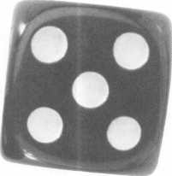

SECURITy

LOCK COMPANY



**New** Factory Replacement Parts and Locks for Security Corporation and Kumahira Safe Co. Products

Safe Deposit Box Locks and Parts BX, KD Automatic Remote Tube Systems (ARTS) Drive Up Systems Vault Doors Night Depositories Camera Systems Key Blanks and Keys Cut to Code

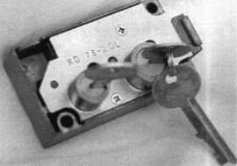

**KD Series Safe Deposit Box Locks**

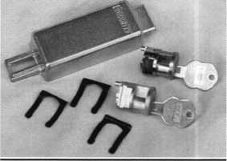

**BX Series Safe Deposit Box Locks** 1155 Chess Drive #114 Foster City, CA 94404 Phone: (650)525-0660 Fax: (650) 525-0444

e-mail : [chaslutz@securitylockco.com](mailto:chaslutz@securitylockco.com)

SECURITy |

LOCK COMPANY I

September 1999

Keynotes

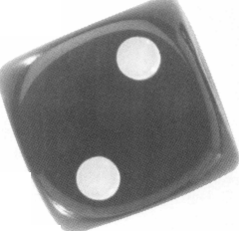

by George A. Sharpley, CML

For the past few weeks, your business has been  
very good and you have been thinking that you  
need another locksmith to help with the work load.

The first thing you should look at is if your  
business has had a steady increase or if the upturn  
is only occurring during a short duration. Most  
service businesses will have periods where the calls

never seem to stop. Then there will be periods of  
time where you wonder if the phone is discon-  
nected. This is very common in all of the service

industry and is caused by factors such as  
vacations, holidays, etc.

If your business has had a steady increase  
over the past months, and you feel that it has  
the possibility to continue growing or

staying at that level, then this is business  
growth. If you feel that you are unable to keep up  
the pace needed to satisfy all your customers, then  
your next decision should be whether you can  
afford to employ an experienced locksmith (if one  
is available), or hire a trainee.

If you are lucky to find an experienced  
locksmith, he still must be trained in your manner  
of business but the period of training should be  
very short.

If an experienced person is not available and a  
trainee is your choice, the next problem is how to  
train that person in the least amount of time so as  
to make a profit from their endeavors. My opinion  
is that a trainee will make little if any contribution



Keynotes

September 1999

to the business for at least six months and very little for the first year. My feelings are that too many employers hire people and expect to make a profit from them before they are trained.

The trainee that you select should be given a good background check as to his schooling, trustworthiness, reliability and whether or not they show the type of dress and demeanor that you want your business to grow on. It is your business reputation that will falter with the wrong selection.

During your interview, you should explain what you expect in the persons training, what they are expected to learn and how long it should take, and what type of compensation you will give as they progress.

My feelings have always been that if a person does not know what a keyblank is and how to identify the different parts, markings and shapes of the blank, they are going to have problems throughout their career as a locksmith. They should know how to cross reference the manufacturer’s numbers and read a silhouette as found in the key blank catalogues. They should be able to see if any alterations have been made to the key they have been requested to copy. Most problems with key blank identification come from the sectional blanks that are used by many manufacturers.

The next problem that trainees have is how each

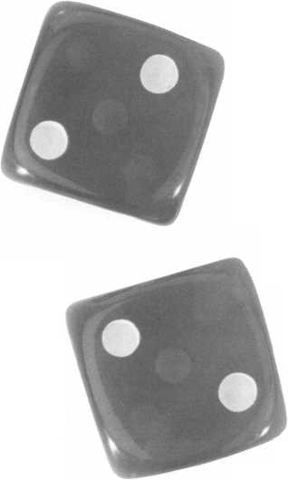

Scholarships are awarded to those individuals who demonstrate their financial need and their desire for more education in the locksmithing field. If you or someone you know fits the above criteria, please fill out the application on this page and send or fax to the ALOA Office at 3003 Live Oak St, Dallas, Texas 75204 by the due date on April 1, 2000. The fax number is (214) 827-1810. Don’t forget to include your letter stating your reason for applying, your three letters of reference and your financial information. No late or incomplete applications will be considered.

Please print or type NAME

ALOA SCHOLARSHIP FOUNDATION, INC.  
ALOA/SAVTA SCHOLARSHIP APPLICATION  
3003 Live Oak Street; Dallas TX 75204; (214) 827-1701

PRP LEVEL

HOME ADDRESS.

CITY.

STATE.

ALOA/SAVTA #.

ZIP.

HOME PHONE.

DOB.

PRESENT EMPLOYER.

WORK ADDRESS

POSITION

EDUCATIONAL LEVEL (**YEARS)** DEGREE, IF ANY_

_ WORKPHONE- FAX

CITY.

STATE.

ZIP

□ FULL TIME □ PART TIME TAKE HOME PAY $_

LENGTH OF TIME IN LOCKSMITHING .

OWNER/SUPERVISOR’S FULL NAME

MEMBERSHIP IN TRADE ASSOCIATIONS (LIST BY NAME). MARITAL STATUS SPOUSE’S OCCUPATION _ COMBINED HOUSEHOLD ADJUSTED GROSS INCOME $_ CLASSES DESIRED

SPOUSE’S TAKE HOME PAY $_

NUMBER OF DEPENDENTS.

DATE OF CLASSES.

ORGANIZATION SPONSORING CLASSES: □ ALOA □ SAVTA □ OTHER (PLEASE NAME).

LOCATION.

ALOA Scholarships are granted to selected individuals desirous of entering the locksmithing field or to selected individuals already in the locksmithing field who wish to improve their professional skills through education.

Applications for classes being taken locally must be received a minimum of 60 days prior to the date of the class, and will be reviewed as they are submitted. Scholarships for classes at the ALOA or SAVTA convention will be awarded each year at the ALOA Scholarship Foundation meeting preceding the convention and must be received by April 1 each year.

Please attach to this form a letter stating your reason for applying for a scholarship, what you plan to do with the knowledge you obtain and any other information you feel may be helpful to the scholarship board in making its decision. In addition, attach three let­ters of reference from individuals who have personal knowledge of your background and character. The letters should contain their names, addresses and phone numbers. It would be helpful if at least one of these references is an ALOA or SAVTA member. Also, please provide a copy of your most recent tax return.

All scholarship recipients will be required to provide a 3x5 inch photograph of themselves.

APPLICATION CHECK LIST

Only complete applications will be considered for scholarships. An application is considered incomplete unless ALL of the above requested information is received before the deadline: 60 days prior to the date of a class or April 1 for ALOA/SAVTA convention classes. Please send this application after checking off each of the below.

* I have filled in each blank on this form.
* I have written and enclosed a letter explaining my reason for applying.
* I have enclosed three letters of reference.
* I have enclosed a copy of my most recent tax return.
* I am submitting this in time to be received 60 days prior to the date of a class or by April 1 for ALOA/SAVTA convention classes.

CERTIFICATION OF APPLICANT:

I certify that the information contained herein, and all supplemental forms are complete and correct to the best of my knowledge. I further certify that if I am selected as a scholarship recipient I will use the knowledge gained for the improvement development and advancement of the locksmithing profession.

Signature.

Date

/.

./

September 1999

08/99

***Keynotes***

Higher

Learning

This year, the ALOA Scholarship Foundation awarded 10 full-day scholarships to ALOA ’99 in Cincinnati. Ask any one of those fortunate recipients and they’ll tell you it was a costreffective and vital way of gaining even more knowledge that’s conducive to their career paths.

Don’t get left out of the mix next year. ALOA 2000 in Las Vegas will provide even more educational opportunities for locksmiths and security profes­sionals. Make time NOW to complete the scholarship application form at the right.

If you’ve never been to an ALOA event, you don’t know what you’re missing. In addition to the selection of classes, there’s much to see and learn throughout the showroom floor.

You too can take advantage of one of our associa­tion’s most valued resources and learn more about different aspects of the trade. So what are you waiting for? The ALOA Scholarship Foundation is waiting to hear from YOU!

THE SOURCE FOR...

**Sargent & Greenleaf**

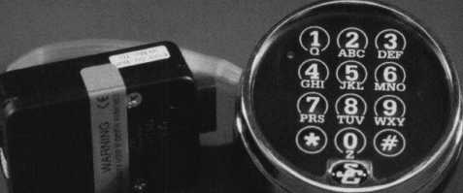

**\* requires an optional module and Time Commander II timelock**

56 **

**tin**

Comptronic Model 6123  
Features:

multiple user

dual custody 0-99 minute time delay  
timelock interface*

Regular price $187.40

Sale $134.95

**IME Tiine-Master.com (web) •[TIMSTR@aol.com](mailto:TIMSTR@aol.com) (email)**

**ASTER 888 798 8464/Fax 800 798TIME(8463)• 785 232 8705/Fax 785 232 2603**

30 I Keynotes

September 1999

super highway. Not only could they give us our medical and employment history, but they could tell us our favorite TV shows and soft drinks.

I have reviewed a number of electronic locks that not only have the ability to identify individual users, but allow different times of access. They have audit capabilities to track who was where and when.

Future generation proximity readers could allow every single door to be electromagnetically locked, while people would walk from one place to another and doors would open automatically if they were authorized to be there. Simultaneously, a tracking system could map their movements throughout the day. An audit might reveal an employee spending two more minutes at the water fountain than necessary, or three separate bathroom breaks.

Technology is neither good nor evil. It depends on how it is used. Knowing the possible capabilities of any given technology can give us a preview of its possible use or misuse. It doesn’t allow us to know if such misuse will actually occur, or who might be the ones to do it.

Being a technician, I am amazed and fascinated by all the new technologies. Some of the capabilities of the various electronic (and computerized) security devices are almost incredible, and yet I know that this is just the tip of the iceberg. The advancements to come, I’m certain, will dwarf the current technologies and then some.

You don’t have to presume evil intent behind the technology in order to be concerned about where it will ultimately go. In countries without a legacy of freedom and independence, technologies that further infringe on those principles and further shred any semblance of privacy are only a problem if they are not also efficient and profitable. There is a rather unique tradition, however, in the United States tracing back to our Declaration of Independence and our Constitution. An efficient, well oiled machine of a government (or society) is not a worthwhile trade, if it requires the exchange of liberty and fundamental individual freedoms.

Locks, security and security devices are, for the most part, good. New technology devices that follow will probably be the same. There are new and incredible capabilities for most types of electronic and computerized devices, which include locks and security devices. How any and all of these things might ultimately be used, has to be considered before they become integral and permanent parts of our society. It is harder to change or reverse course after the infrastructure has been put into place and everyone accepts certain things as normal and acceptable. Whether an electronic card key becomes a government mandated personal identity card is just speculation. But it is hard to regain a freedom, if you don’t even know that you have lost it. The many advances in technology demand that we more seriously contemplate the possible unintended consequences and side effects. It is a delicate balance to maintain our security without surrendering our freedom.

TouchAccess’

An Intelligent Lock

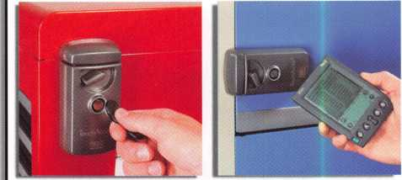

TouchAccess features:

* Mechanical lock-activated ONLY with authorized user key
* Accepts up to 525 unique key IDs
* Keys cannot be duplicated
* Programmable access times and days for each user
* Records user ID, date, and time of each entry
* Stores the most recent 526 entries
* Access log retrieved using a Palm III organizer

**rrWVflHHD] *Call for a free information* llbUriLaJJ *packet todayl***

1105 N.E. Circle Blvd., Corvallis, OR 97330  
541-758-0521 **•** Fax 541-752-5285 **•** [www.videx.com](http://www.videx.com)

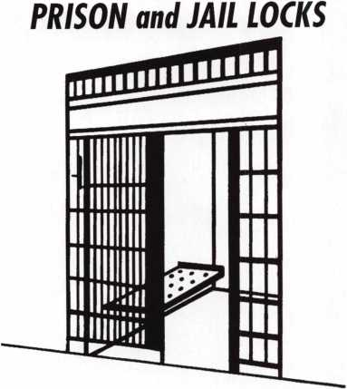

Qeorg,e cA. Keene? 3nc.

1101 NIAGARA FALLS BLVD.  
BUFFALO, N.Y. 14226  
PHONE 716-832-0180  
FAX: 716-832-5422

September 1999

Keynotes



**Security, Technology**

**and Privacy**

by Sal Dulcamara. CML

A very rough paraphrase of a quotation attributed to Thomas Jefferson, goes something like this: “Those who would trade their freedom to gain security, deserve neither.” At first glance, the idea seems a bit extreme. We often make subtle concessions of our freedom in exchange for increasing our security. What harm can there be? Isn’t it better to be safe than free? If we have nothing to hide, why do we need privacy? Doesn’t the government know what’s best for us, anyway?

Being both an American and a security professional, I sometimes find myself conflicted by what seems to be contrary objectives. Security, in its most extreme version, requires strict controls with little or no unplanned or unobserved movement. Access by unidenti­fied persons is unacceptable. Closed circuit TV cameras mounted on street corners can sometimes reduce crime rates, but doesn’t that sound frighteningly like Big Brother watching us? Twenty-five years ago, when I was still in high school, I was interested in writing fiction. I was a fan of science fiction, and remember the various stories that predicted ominous consequences for the future.

It is amazing the rules, regulations and practices that most of us

accept as standard operating procedure. The searching, observation, and invasive physical scrutiny that we tolerate of our persons and possessions, we chalk off as the price we pay for our security in a dangerous world. If many of those things were described in story form just 20 or 30 years ago, many of us would have thought that it was frightening. But we would have followed that thought with the presumption that the story was entertaining, but just the results of an overactive imagination by some science fiction writer. Maybe in some far off totalitarian regime, it could happen. Of course, those kinds of things could never happen in America.

Many new technologies are just in their infancy. Universal identity cards are not far off. We, in the security business, are quite familiar with card access technology. Smart cards are getting even smarter. It is not far fetched to think that a smart card (in the not too distant future) could have our entire life histories stored on them. With biometrics, our palm print or retina pattern can identify us. It is not a stretch to think that we could walk into a government office, and after being scanned and identified, everything about us could be revealed by a massive database stored somewhere in the information

Keynotes

September 1999



in the long term due to human nature of wanting to live in a relaxed lifestyle.

This is the same for many of the other programs that this study said showed no evidence of being effective. From the locksmith's point of view, there is very little that we can do that will not work! You may present the argument that if you were to give a talk at the senior citizens center on the good and bad points of deadbolt locks that you are wasting your time. I would argue that while you may not get the seniors to do anything but fall asleep, the people who run the center will be listening as well as the people who brought the seniors to the function! They are prospective customers too!

**WHAT IS EFFECTIVE?**

It is important to talk to your neighbors, to the nonprofit groups, and anywhere else that an invitation may be derived. Talking is not cheap but it is an effective way to promote crime prevention on physical security and to promote your business. I was not a very good orator in the beginning and began my efforts at neighborhood watch programs. I would offer programs on physical security after the police finished their end of things. I made up pamphlets to hand out after the meetings along with my business cards. I ended up talking on the nonprofit club tour of the area (Lions, Elks, Civitans, etc.). I enjoyed good company, good food and made a good number of friends. It was a scenario that gave me good job prospects then and now, 20 years later, those speeches are still bring work through the door. It is easy to conclude that talking works!

It is important to set the example since it is the easiest way to be effective with kids. Other than physical security, the 1997 report indicated that programs like DARE were effective. In fact, the most effective were programs where you had a captive audience like kids and infants or where there was a haven from trouble. The haven would be the case of protecting battered women. It stands to reason that if you, as an individual, wished to become more effective it would be with kids. You could work with the Boys Club, Girl Scouts, Boy Scouts, or church groups. These would be things that lie outside of the locksmith business but will promote your business as effectively as anything else you

could do. It will promote you and make your efforts in all areas taken more sincerely by the public. I chose the Boy Scouts and church groups and the end results were a much improved relationship with the police department as well as a highly accepted profile with the general public.

All of this was good for business. There are other ways to promote crime prevention but remember the central idea that lock- smithing is a business. This means that while you build a business over time, keeping a good reputation, you must look for the opportunity to speak. When break-ins begin occurring in neighborhoods start talking. When the employees start stealing the company toilet paper and cleaning supplies start talking. Only when people become afraid of a situation will they begin to listen.

**THE FINAL OBJECTIVE**

It is therefore very important for us to remember not to take our steps towards crime prevention too personally. We have a tendency to do that! We give talks on security and then do physical labor to install the locks and security systems that will make a difference only to have the customer not use it and suffer a great loss. We end up having a temper tantrum and feel used. This is total nonsense! We were paid for our efforts. We did not give our services and talent away. The customer has the right to

use the product any way they want to. Like I said earlier, wisdom is expensive!

I am not saying that we should not be passionate about what we do. We should be very passionate! Locksmithing is what we are and what we represent. We live and breathe it. Some of us even sleep with it. It is, however, important that we not take acts of crime personally. Be passionate in what you do, and passionate in your distaste of the audacity of the criminal and what he does against society. Remember that you have done all you can do, if you have done your job. The act of catching the bad guy is someone else's job.

In a final note, there is one important factor to give heed to. Everywhere I look this summer, there are banners and slogans for people “not to sweat the small stuff!” Go to work and make money and inform the public of physical security and then go home! Go home to the family and the blessings that you have earned and have been given! Only by doing this will you have the strength to fight tomorrow's battles. To answer my doubts, I would have to make this conclusion. Yes, crime prevention matters. It will give us our tomorrow and our children their tomorrow. It is up to you! How passionate are you willing to be?

**RESOURCES**

PREVENTING CRIMES: What works, What Doesn’t, What’s Promising  
<http://www.ncjrs.org/works/index.htm>

PROGRAM IDEAS

from the National Crime Prevention Council  
<http://www.ncpc.org/program.htm>

Crime Prevention Coalition of America  
<http://www.crimepreventioncoalition.org/>

World Wide Web Sites for Crime Prevention  
http: // www. nc j rs. org/cp www. h tm

Lewis’ Prevention

<http://www.twp.cranberry.pa.us/Lewis/crimepre.htm>

Get Involved In Crime Prevention  
http:// [www.usdoj](http://www.usdoj) .gov/kidspage/getinvolved/

September 1999 Keynotes L

**OUR POLICE DEPARTMENTS**

The $2 billion dollars that I have referred to is only a part of what the police depart­ments receive from the Federal Government. There are special funds that go to special programs and there are funds that are received from state level programs as well as revenues from local government. All in all, it is still not enough to get the job done. It is a massive job with little satisfaction for the

participants on the justice side! I don't know what the satisfaction level may be on the bad guy side!

To make a very long list very short, anything that we do from driving a car to breathing in fresh air or drinking clean water can be and is affected by crime. There is crime in industry, in dumping our garbage, in drugs taken by kids and adults, in attitudes of interaction between adults as well as kids. The list is endless. It seems to boil down to who is going to take the

responsibility. So far, society has elected local, state, and federal police groups. The money is given and they try to solve the problems. Accountability is not as important as just solving the problem! Simply throw enough money at it and someday the problem will find a solution.

The 1997 study said that only with accountability could it be determined what programs are workable. It is tough enough for our police officers to fight a fight much less a lost cause! Even with the differences between the police establishments and the locksmith industry, it will take everyone doing their share if we are to take this battle with crime seriously. Equally important, it will take a better effort of our elected officials to make accountability count. Until this happens, crime prevention on the national level will just aimlessly lumber along.

**WHAT DOESN’T WORK?**

When we look at the options that are open to the locksmith, there are many. There is, however, one central idea that runs through anything that we do. The locksmith does what he does to make money. This is our business. Yes, don't get me wrong, there is also a responsibility to the intrinsic values of our society. It is our responsibility to teach those that we work for and those in our community, what it takes to be safe and secure. One way to view this is that we do our level best to put ourselves out of business! Thankfully, people do not fully listen and do not fully act upon what they learn. This attitude is human nature and from the business standpoint, I have been very thankful for it! From the personal viewpoint, it is very sad! Wisdom is expensive. Most people will not learn until the disaster strikes and they will only remember and practice what they have learned until the danger has passed!

Just because it is human nature to be complacent, we need to see that when apathy is absent, it is our time to act. Yes, we are acting to make money as well as to teach and inform the public of what they can do to protect themselves. The study of 1997 indicated that the neighborhood watch programs gave no evidence of working. I would think that this is for the long term. The program works when the action of burglaries and assaults are taking place and everyone is living in fear. They do not work

Marray Introduces... Factory Direct Prices

Electrified

Locks...as low as $142.00  
Hinges...as low as $64.80  
Panic bars...as low as $193.05  
Trim...as low as $270.00

WOW!!

Best Price Guaranteed!

What are you waiting for?

Call Marray Today  
1-800-500-1449

Marray. Your first source for UL listed & modified hardware.

*m* Marray *enterprises, inc.*

**At** Marray, we’re not just modifiers, we’re Master Hardware Modifiers™  
**1128** Walsh **Ave., Santa** Clara, CA **95050.** [www.marray.com](http://www.marray.com)

VISA, MASTERCARD, COD. OPEN ACCOUNTS A.O.C.

Keynotes

September 1999



Here I am, approaching 30 years of locksmithing, with a concern of writing about one of the most important parts of my job. I thought how simple it would be to write about crime prevention. It wasn't until I began that I realized that much of what I thought I had done or even accomplished in my community might have been wasted efforts.

Crime Prevention is an area of activity that we, as a society, want to work. We want to do something good for what we have been given in this life and to make our communities a better place to live for our neighbors, our children and ourselves. For the locksmith, this is especially true! Just about everything we do is centered around preventing crime in our community. I have been on the local lecture tour with many of the non-profit organizations including senior citizen centers teaching ways of keeping people and their possessions safe. I have talked to kids and given tours of my shop. I have taken part in the local events that highlight summers with displays of locks and home security and talked until I could talk no more. I have been to neighborhoods with the arsenal of displays and seminars. I just can't help but wonder if it all has really made a difference in the safety and security of my friends and neighbors. It is a little bit like the movie It’s a Wonderful Life with Jimmy Stewart. Only Clarence, the angel, never showed up!

A BRIEF HISTORY

Working on this article has led me to a great deal of research and some very interesting answers. The boring part and somewhat surprising discoveries lie in the history of it all. The concept of crime prevention has been on the books for 30 years! That’s right 30 years! Half of the Department of Justice budget ($2 billion dollars) is allocated towards crime prevention! Actually, it is more than that!

The $2 billion dollars is just for the support of the police depart­ments across the country. The next surprise for me was to find that after all of this time there still is not any means of deciding what works for crime prevention and what does not! I know that sounds crazy, paying for something and then not know if it works or not, but that's what happens in government. It is true however, that not until a report in 1997 did Congress find out that there is a lack of informa­tion gathering and on sharing what information is gathered. There is also no method of evaluating what is taking place with the programs that have been implemented!

It was in 1996 that an independent committee out of the University of Maryland was awarded the job of finding out what programs in crime prevention worked and which ones did not. The findings of this committee gave conclusive evidence to a positive effect of programs in five areas. These are in the programs of DARE, Battered Women, Weed & Seed (an infant abuse program), the building of new facilities for crime prevention (i.e. a new school building and prisons), and in areas of physical security. All of the other areas either had no accountability or what was available was incomplete. In 1997, the report resulted in the Senate bill requiring 10 percent of the allocated budget to be set aside for the purpose of assessing a program's effectiveness. The House version eliminated the requirement and the effort eventually failed. It appears from what I can find that we are no better off than we were before! I found all of this to be very disturbing.

September 1999

Keynotes I

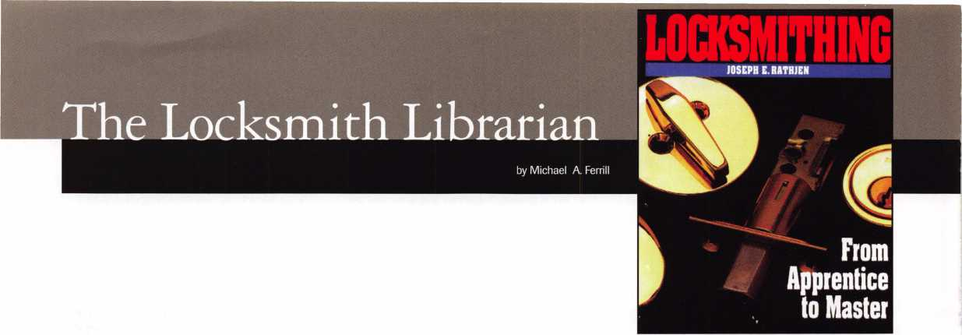

**The Locksmith Librarian:**

**Comprehensive Manual of Locksmithing**

by Shankie & Shankie (1994)

Royce H. Shankle and Mary D. Shankle published an excellent book about locksmithing entitled Comprehensive Manual of Lock- smithing in 1994. The book itself is not only an excellent resource guide but very comprehensive.

The book is 584 pages and covers 20 complete chapters of basic, readable and knowledgeable information about locks. From the first chapter entitled “Pin Tumbler Cylinder Locks and their Keys,” to the last chapter entitled “Electrical Control Systems,” the reader is provided basic and necessary knowledge about the practice and art of locksmithing.

For students attending the Pine Technical College in Pine City, Minn., this book is but one of four important texts used as primary reference guides to classroom instruction. The Senior Instructor at Pine Technical College responsible for the Security Technician/Lock- smithing Program is an ALOA member, John Heckman, CML. John uses this book as a teaching guide to assist his students in acquiring basic knowledge about locksmithing.

The book covers a number of important items and topics such as services, high security locks and their keys, disc “wafer” tumbler locks, warded locks, automotive locks, vending machine locks, combination locks, keyed pad locks, keys and cross reference and a complete and simple chapter on starting a new locksmith business.

The book is well written and contains a great deal of information. In fact, the first chapter alone covers 42 pages of data concerning pin tumbler locks, from identification of basic keys to simple yet effective repinning techniques. Chapter 7 discusses Master Keying and authors ensure the student understand the basic but simple require­ments to establish a Master Key Program. It is taught in textbook instruction and simple to understand.

If I were a beginning locksmith and wanted to learn more about this trade and profession, this would be one book I would certainly add to my library.

**Locksmithing: From Apprentice To Master**

by Joseph F. Rathjm, Fourth Edition (McGraw-Hill, 1995)

As we continue to read more about the art and practices of Lock­smithing, a book concerning this subject is now available in print, and can be purchased through a number of National Books stores. The title of this book is Locksmithing: From Apprentice to Master, by Joseph E. Rathjen.

Mr. Rathjen s book provides a very good study in several areas of our profession. His initial chapters explain very basic requirements necessary for seeking education and career opportunities in Lock­

smithing. Chapter 3, identifies the basic tools of the trade. His additional chapters in Securing Employment (Chapter 4) and obtaining advance certification (Chapter 6), outline some useful information for the beginning locksmith that establishes the basic building blocks for his professionalism. This information will also enable him or her to begin establishing trade skills in this field. Although Chapter 7 outlines some general locksmith laws for the state of New York, it would be reasonable and necessary to review your own state laws and requirements in this field. Chapter 8 explains to some degree the necessary requirements to set up a small one-person shop. This is helpful information for the majority of locksmiths that practice in our country since the majority of our locksmiths in this country are in fact one-person shop owners.

Part two of this book covers subjects and topics in areas related to basic and advance locksmithing techniques. Types of locks, lock design and functions, high security locks, keys and cylinders are clearly identified. Even a chapter on Door Closers, another field that compliments our profession is explained is some detail. Master Keying of locks is written in easy to understand terms. Interchange­able Cores is plainly explained and shows a simple and workable system that is identified through superb art work. Chapter 16 explains Automotive Locksmithing, and the final chapter 17 covering Modern Alarms covers 48 pages of basic and useful information concerning control panels, basic electrical circuitry diagrams, tools, and basic installation techniques. The book is professionally laid out in good readable type, and the graphics and photographs are clear.

At the recent Master Locksmiths Association of New Jersey, 68th Anniversary Convention, in Somerset, New Jersey held on the 18th - 21st of March of this year, a ALOA ACE certification course was taught by Mr. C. Allan Halverson, who is a publisher author and leading industry expert in the field of Locksmithing. Mr. Halverson, used this book as a basic resource guide and teaching tool for those locksmiths enrolled in this course of instruction. The book was highly respected by the students.

Locksmithing: From Apprentice to Master is an excellent resource guide, and should be added to any locksmith library, as an important reading and teaching tool that provides a wealth of basic information and knowledge concerning the field of locksmithing. If I were a beginning locksmith, or even a master locksmith this book is well worth the time and effort to review, and study.

(Editor’s Note: Locksmithing: From Apprentice to Master is available through the ALOA Bookstore. Call (800) 532-2562for details.)

September 1999

241 Keynotes

Over the next several months, I will define what makes up an alarm system, how to select equipment, how to install it, and how to diagnosis and correct problems. Before we discuss anything regarding an alarm system, it is important to remember that a contract with your customer is mandatory. It should specify your responsibilities, liquidated damages, costs, insurance requirements, terms for canceling and other items as directed by your attorney and insurance company. This month I'd like to start with some information about the alarm industry, how it differs from the lock industry and finally some of what an alarm system is and how it works.

The alarm industry, as might be expected, deals with a different set of rules than the lock industry. In the lock industry, once we've collected for a sale we can expect no further revenue from it. We may provide further materials or services to the customer, but in general most sales generate all of the profit from it at one time. In the alarm industry, much of the profit is derived from RMR (recurring monthly revenue). I've seen central stations offering to monitor accounts for as little as $1 per month, the monitoring service we use runs $5 to $7. We use them because of the excellent service we receive. Considering most alarm companies charge an average of $25 per month it's a significant mark up. The down side is many low end marketing companies offer to practically give away a basic system to get an account. I've seen ads for anything from Free to $199-95. Once they get their foot in the door, the salesperson hard sells or attempts to up sell the system adding in extra door/window contacts, motion sensors and other parts.

This makes the average cost of those systems, according to one of the well known low end marketers from five years ago (the only statistic I could find on this type of company) around $1000. Since that time the overall industry average install cost has gone from $1200 to around $2000.1 think this means the low end marketers are moving into the realm of realistic install rates and those of us who quote a realistic price to begin with will actually be able to charge a fair rate for our time, without having to hard sell the customer.

Another major difference in the alarm industry is the selection of equipment. In the lock industry, we typically do not pick the equipment installed at a customers location. Occasionally, we have input when the building is being built or during a rekey we can upgrade to a high security cylinder, but for the most part our customers already have

locks when we get the call. The alarm industry is different in that we normally choose the equipment to be installed. In addition, we typically don't work on systems that we didn't install. This is because of both liability concerns and if you are working in another company's system you may not be able to put the system in test (to prevent a false dispatch), and you may not know the proper code to access the programming. The benefits are your customers are somewhat locked into you for service and repair, and most if not all of our alarm customers also use us for their lock work. Our company currently uses two different manufacturers burglar alarm panels. This makes program­ming and inventory simpler. Tools are another difference between the industries. Many hand and power tools are common between the two industries, like a standard assortment of drill bits, but how many of you carry one to six foot long drill bits to reach into attics or basements. There is also a wide range of wire fishing and pulling tools available. Volt/ohm meters and other electronic tools round out the compliment of specialized tools needed. If you install electronic access control you should have most of the tools already. A future article will deal with specialized alarm tools.

An alarm in its simplest form is a power source, an on/off switch, a trigger switch and a noise maker. In its most sophisticated form, only a few more parts are added to create a control panel. The trigger switches are more complicated, and there is a method to communicate to another location, while the basic idea is the same. If the alarm panel is turned on and something trips the trigger, the alarm will sound. This is similar to the lights in your house. If the circuit breaker (the alarm panel) is turned on, and someone flips the light switch (the trigger) then the lamp (the noise maker) will light. The trigger of an alarm panel may be a magnetic contact, a motion sensor, or any one of a number of different devices which will be covered in future articles. In the same way as turning a light switch on will not cause the lamp to light when the circuit breaker is turned off; the alarm will not sound on the alarm panel if it is turned off when a motion sensor sees movement or a door is opened.

Let's look at the parts which make up most alarms. We start with a transformer providing an output voltage around 16 volts. This will feed power to the control panel.

The control panel can be compared to the power supply and mother board of a computer. The next component we find is the keyboard. Keyboards for alarm panels

also contain the monitor or display. Next, we need some input devices or triggers. These may be magnetic contacts used on doors or windows; motion sensors like passive infrared sensors, or microwave detectors; glass break detectors like window bugs which sense the shock waves of glass breaking or acoustic microphones listening for the sound frequen­cies of breaking glass; hold up switches; smoke or heat detectors; gas detectors; or any one of many other forms of input sensors. Lastly we need an output device, in most cases it will be a siren or speaker with a siren driver. Another output may come from the panel in the form of a modem calling a central station or a pager. This article discussed the differences between the alarm industry and the lock industry. We've briefly explored how alarm systems are priced and some of the different installation tools. Finally, a very brief description was given on how an alarm system is put together. Our next article will deal with alarm panels, the different types of panels and what they do, how to program, what needs to be programmed, and why. Future articles will deal with input sensors, wire fishing, fire alarms, troubleshooting and more.



**SAFE CORPORATION**

MANUFACTURERS OF QUALITY DEPOSITORY SAFES AND CHESTS

DISTRIBUTING FROM WAREHOUSES IN

* LOS ANGELES**,** CA
* CHICAGO, IL
* GLASSBORO, NJ

A&B is now a stocking distributor  
for Mutual Safes featuring

TL-15 • TL-30 • BISCHOFF CUB

Choose from over 75 models in stock

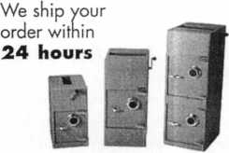

See us at [www.a-bsafecorp.com](http://www.a-bsafecorp.com)

800-253-1267

Fax 856-863-1208

CALL FOR YOUR CATALOG TODAY

September 1999 Keynotes



ASSOCIATED LOCKSMITHS OF AMERICA, INC.  
MEMBERSHIP APPLICATION

Welcome to the Associated Locksmiths of America, Inc., an association for persons involved in the security industry as  
locksmiths, security consultants, educators, manufacturers, or distributors.

To apply for membership, please complete this application and submit it with the application fee, dues for the current  
year, and your business card, company letterhead, or suitable proof of employment.

All of the following questions MUST be answered before this application may be processed. Please type or print.

TYPE OF MEMBERSHIP

Please check only one.

* ACTIVE MEMBERSHIP Individuals have actively engaged in supplying, servicing, or  
  installing security hardware for a period of not less than two years.
* APPRENTICE MEMBERSHIP Individuals who are in initial training and meet all the  
  requirements for Active Membership except for the length of time in the security industry.
* ALLIED MEMBERSHIP Individuals whose position in the security industry relates to  
  the aims, policies and promotion of the locksmith and his/her craft.

CANDIDATE INFORMATION

Name: MR. MRS. MS. [circle one)

Business Name:

Business Address:

City: State: Zip Code+4:

Work Phone: Home Phone:

Home Address:

City: State: Zip Code+4:

Social Security Number: Date of Birth:

Send mail to: □ Business □ Home

Directory Listing □ Business □ Home □ None

APPLICATION AND FEES

A $40 application fee, appropriated annual dues, and your business card, company letterhead, or suitable proof of employment must accompany this application. Dues include $25 subscription to Keynotes monthly magazine. Your second year’s dues will be prorated based on the date your application was received by ALOA.

Be sure to include appropriate fees  
and information:

* Letterhead, business card,

or other proof of employment

* Application Fee $ 40.00

ANNUAL DUES:

* Active/Allied Member $125.00
* Apprentice Member $ 75.00

OTHER FEES:

* Canadian Air Mail $15.40
* Overseas Air Mail $ 37.40

PROFESSIONAL INFORMATION

TOTAL ENCLOSED $

Are you a: □ Sole Owner □ Corporate Officer □ Partner □ Employee □ Student  
Are you currently engaged in the security industry?: □ No □ Yes,years  
How did you learn locksmithing or security work?

Are you a member of a local locksmithing association? □ No □ Yes

If “Yes,” please provide name and address of association^):

METHOD OF PAYMENT

* Check [payable to ALOA in U.S. funds)
* MasterCard □ VISA
* Discover □ American Express

Please note, if you are sponsored by an ALOA member, your application will be immediately processed with  
a 90 day probation period. Otherwise, final processing takes up to 120 days.

Names and addresses of two industry-related references (required):

Card Number

Expiration Date

Please print name as it appears on card

IMPORTANT!

Have you ever been convicted of a felony?

* No
* Yes (If “Yes”, please give details on a separate sheet.

All felonies are reported to the Membership Committee for review)

/ certify that all statements are true and\ if accepted as a member, I agree to abide by the rules,  
regulations, and Bylaws of ALOA, and further agree to adopt the Code of Ethics of ALOA as my own,  
and adhere to it to the best of my ability. Should my membership be discontinued, / agree to return  
my membership card, and cease use of all ALOA insignia.

Signature

Date

Cardholder’s Signature

FOR OFFICE USE ONLY

AMOUNT RECEIVED

APPLICATION FEE

DUES

RECEIVED BY

APPRENTICE TRANSFER

NUMBER

DATE RECEIVED

DATE APPLIED

APPLICANT LISTED

IN KEYNOTES

Mail or fax completed form and payment to: Associated Locksmiths of America, Inc., 3003 Live Oak Street, Dallas, Texas 75204

ALARM BASICS

**PART 1**

BY GREG PERRY, CML, CPS

ALARMS

**alarms are broken into less frequently and when they are broken into the amount of loss is smaller. Many**

**of the studies I've seen indicate that buildings without alarms are two to three times more likely to be**

**broken into and when they are broken into they suffer four to five times the loss of a protected building.**

**All the physical security protecting a building cannot stop a determined burglar and once it's been**

**defeated offers no more protection. An alarm system not only helps deter a burglar, it can also notify a**

**central station of the intrusion. As a locksmith and alarm technician, I'd like to think a good locking**

**system and an alarm system combine to create a secure environment which will deter most burglars and**

**notify the police for the ones it doesn't.**

22

***Keynotes***

September 1999

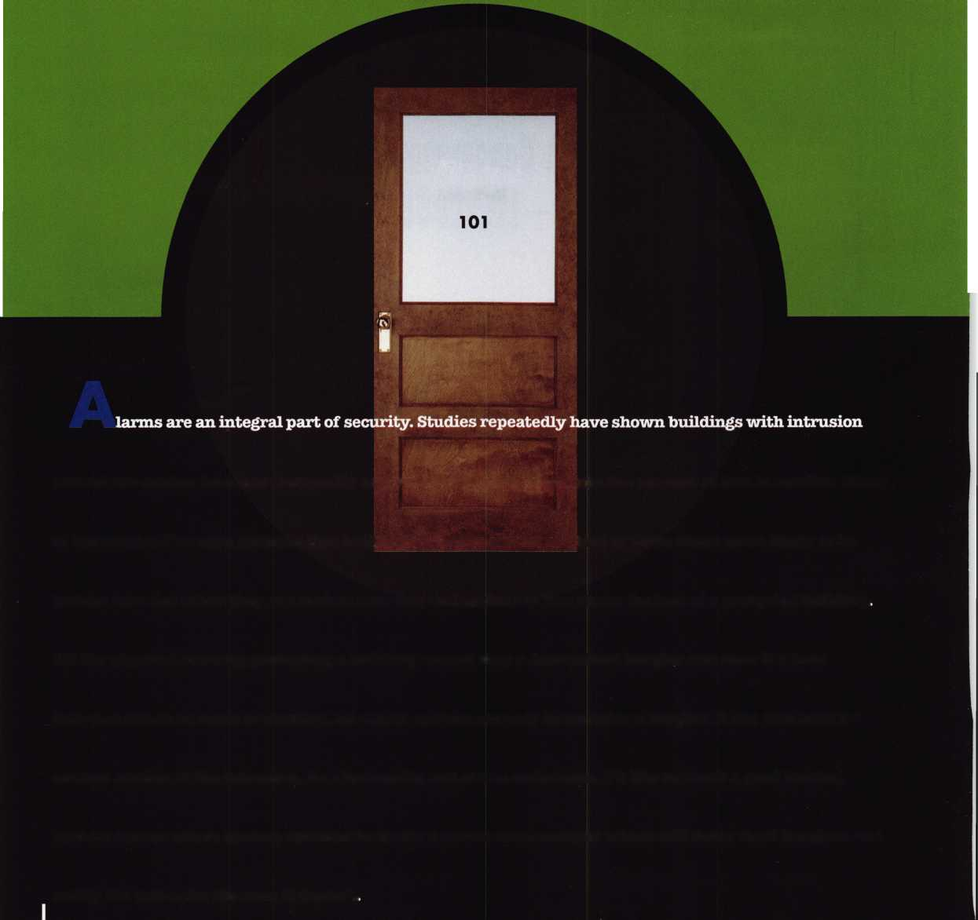

**Door and Hardware Institute’s 24" Annual Convention rnd Deposition October 16-18,1999**

Take advantage of more than 420 exhibit booths and 20 educational sessions covering topics such as:

* Security applications in the next millennium
* Successful electrified hardware project procedures and documentation
* Code requirements for electrified hardware
* Life safety codes and ADA

**For a convention brochure and a registration packet, contact us at:**

.TIT* Door and Hardware Institute *1' ™ Attn: Meetings and Conventions Department

14150 Newbrook Drive, Suite 200 Chantilly, VA 20151-2223

* 703/222-2010 **★** Fax: 703/222-2410 **★** Website: [www.dhi.org](http://www.dhi.org)

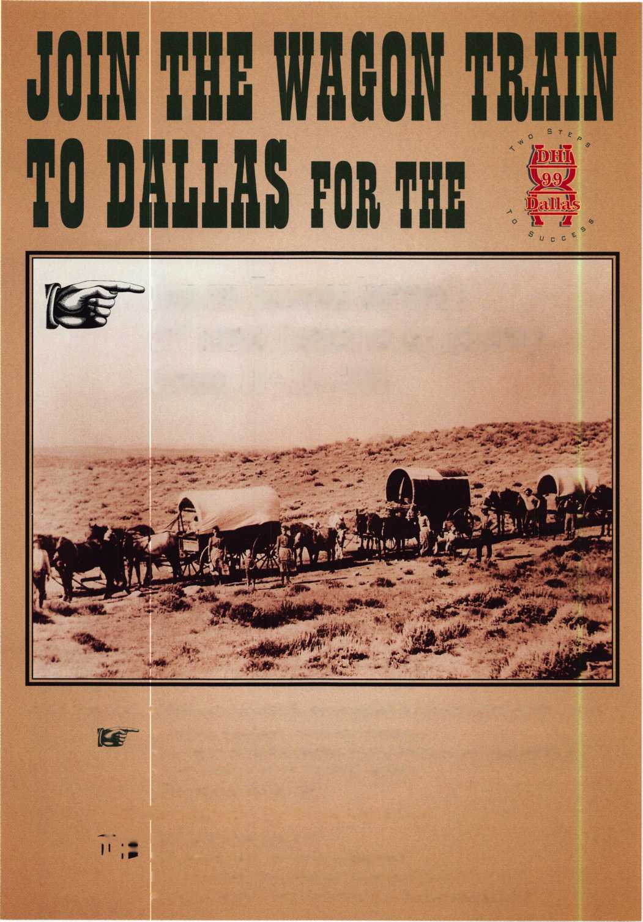

^

I



**BE A PART OF 1-800-LOCKSMITH!  
USE THIS NUMBER IN YOUR CITY  
& OWN THE MARKET!**

We are looking for qualified locksmiths who want to expand their business

and develop themselves into one of the largest locksmith operations

in their city. You will be authorized to use our logo and name

and we will advertise for you on radio and television.

Interested locksmiths will be able to "secure"

as large or as small a territory as they

desire. Territories will be based

on zip codes.

**Call today for  
more information  
or to sign up!**

Keynotes

September 1999

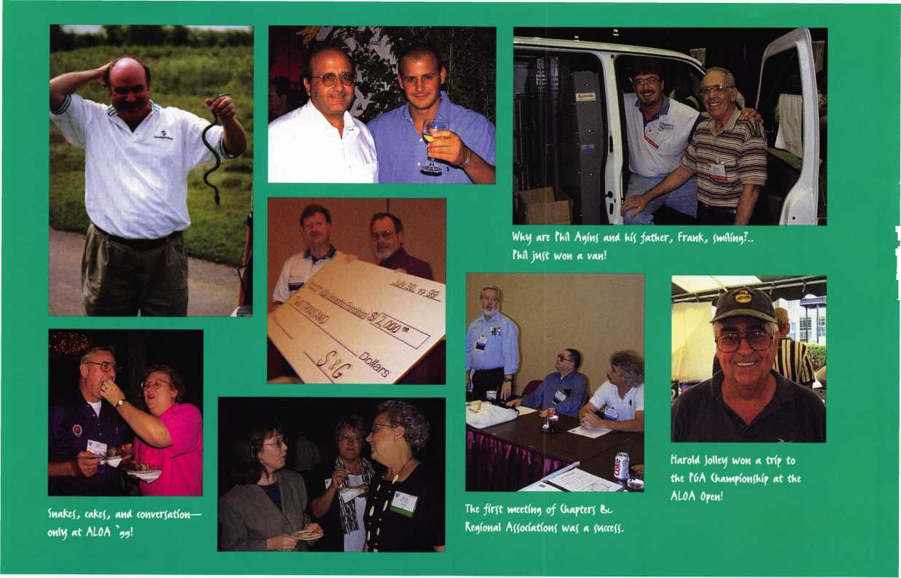

September 1999

**ALOA for life!**

lift **vwwiberf provwllvj fkow tkw'r** aWar^.

**bepArtiwq Eoah* Member, Dama iforvinm., ft reco^niZ^ed At tke ALOA Memberfkip Meeting.**

**Jokn** (ammom Accept! **tke fretfdeiit'f AwAr* from DaIIa( (. Brookf.**

**Attendee! ^et a kick out of Medeco Kick-Off fArt^ entertAinerf-  
JaZ*z* bAHd “Kick (Me Skeleton.”**

**Attendee! line up for tkc Secvtr**'\ty **E*po Ki'bbon Cutting**

Kecentty depArted inftructor Oarvj (Hover !luircd MiAM^ UVtykf At ALOA ^9.

**Medeco !**)ot\j **Kih^wah prefent!**

&AVt'd fAUlflMd Wltk A dOMAtlOM for

**tkc ALOA SckoUrfkip** FovtndAtion.

frodMCt demonftTAtlOn! Were A COMjtAMt on tkc (kowroom floor.

|  |  |  |  |
| --- | --- | --- | --- |
|  | mj“ ■ |  | u1" |
|  |  | m? j |  |
|  |  |  |  |

|  |  |
| --- | --- |
| t# |  |
|  | ft |
|  |  |
| V | ■  > * ’ |

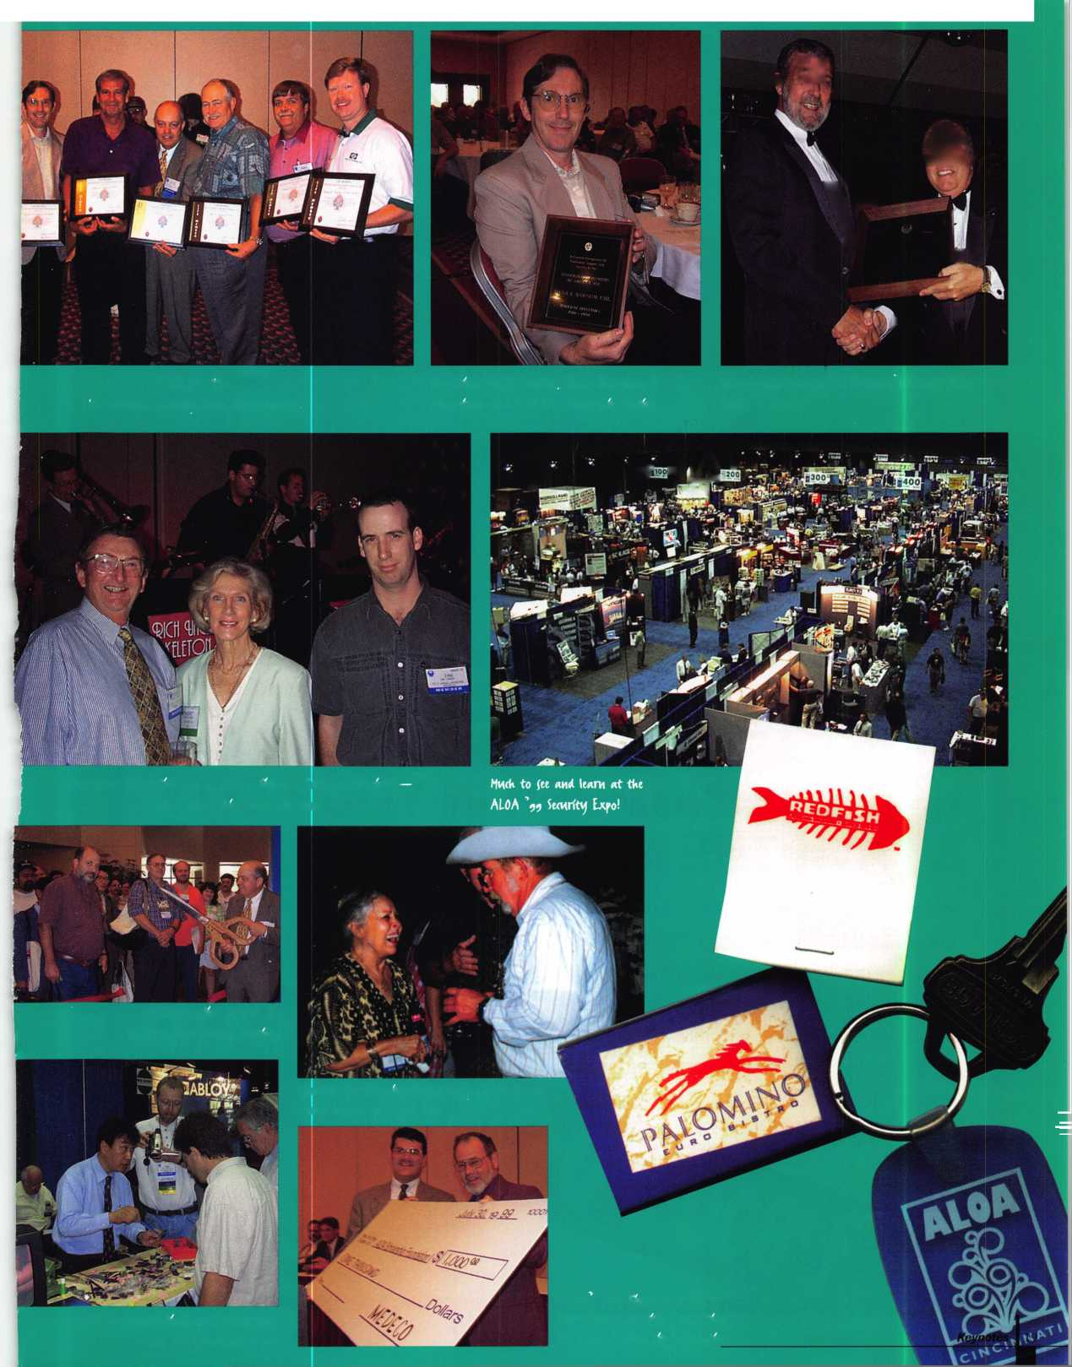

i for every!

**Good-bye Cincinnati, Hello Las Vegas**

Well, it was here and gone before anyone knew what happened. Yes, ALOA’99 in Cincinnati was an event to behold. Of course, don’t just take our word for it. Just look at the pictures! From the smiling faces, anyone can see that it was a resounding success for everyone involved.

From the showroom floor, which featured the industry’s top exhibitors to the classes that were taught by some of the leading instructors in the security field, it was truly a week to remember.

Of course, kudos must go out to Medeco for providing an outstanding Kick-Off party, complete with a beautiful fountain centerpiece and live swing music. And let’s not forget the contributions made by Meilink, who sponsored the wonderful Banquet. Aside from an elegant dining reception, the event also featured a musical review that told the story of Meilink’s 100 years as a safe manufacturer.

The city, itself should also be credited. With its dazzling skyline, historic architecture, bustling entertainment and convenient facilities, it was a fitting site for this year’s show.

ALOA 2000 is already in the planning stages, and judging from its location—Las Vegas—there’s little doubt that it will be a great start to the new century! Until then, enjoy these sights from ALOA’99 and Cincinnati!

Keynotes September 1999

**Me«Uco’f feter Fieto A«eptf tke ALOA Lifetime of Aduevevnent AwAta from Stan**

**i(m t a(** far aWa\j **a( vjok tkink!**

**It** wa\j **take** a **wkfle to recover from tke**

**bfy time** Wtuk **bvj** All At **ALOA !**

**ALOA f** )apah (kApter wa( **one of** wiamvj **internAtioMAl ^ronp( repre(ented.**

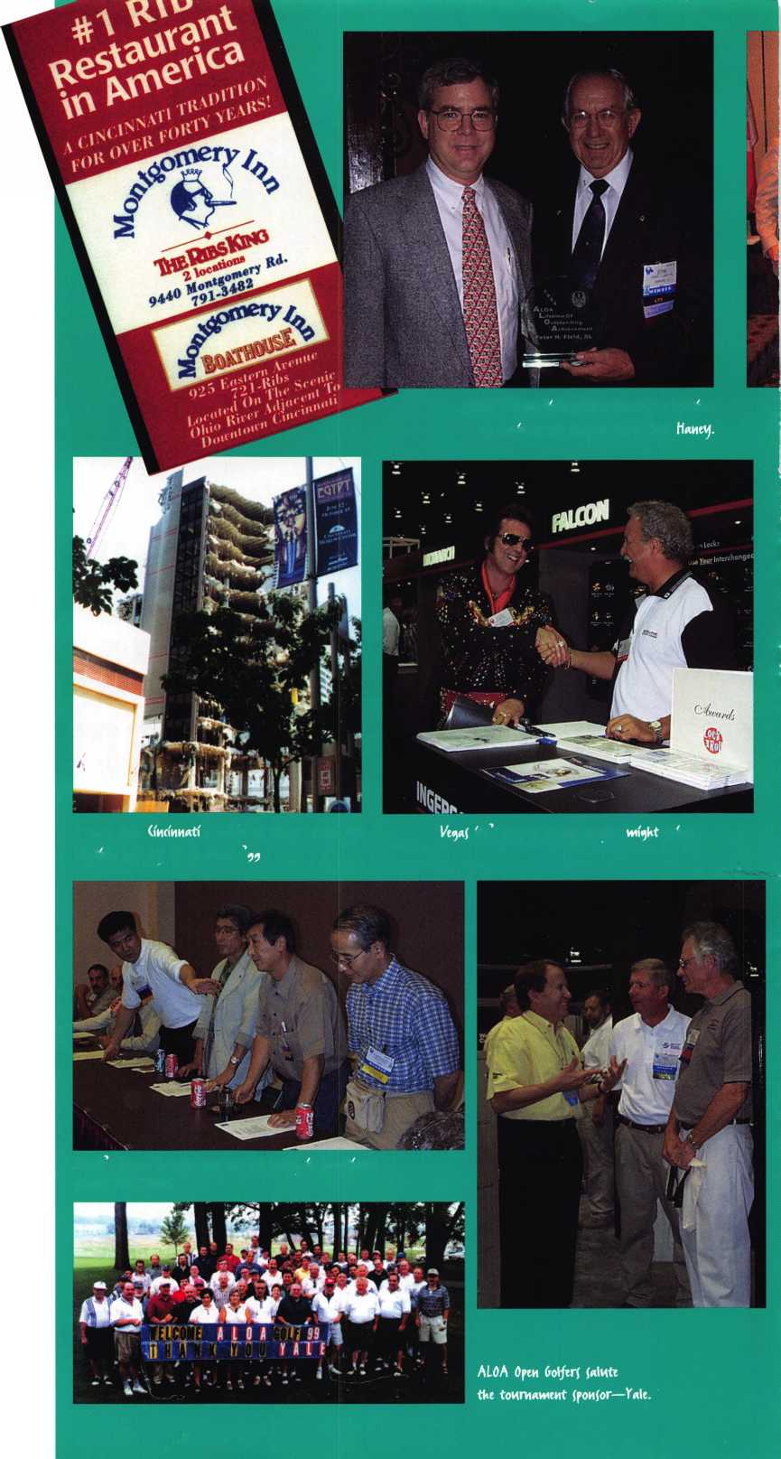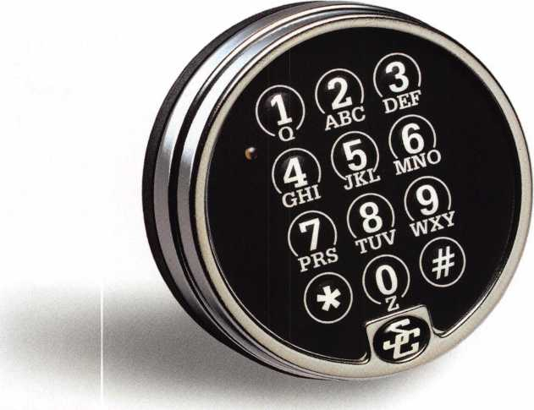

Simple Installation.

Quick Access.  
Maximum Security.

Choosing the right product, to meet your customers’ needs —as a security professional you’re faced with this nearly every day. And that’s exactly why you should specify Comptronic™ electronic safe locks from S&G.

With the Comptronic...

* there’s nothing to mark, measure or cut. With a standard footprint, just mount, plug in and your job is done!
* there’s nothing to spin, turn or retract. Simply punch in the access code and the Comptronic does the rest - automatically retracting the bolt for quick access.
* there’s no day-locking. After the bolt is retracted for six seconds, it automatically relocks, ensuring that the safe is secure against unwanted entry.

Call your authorized Sargent & Greenleaf distributor and order the Comptronic model that meets your needs. For specific product literature phone 1-800-826-7652, ext 315, or visit us at [www.sglocks.com](http://www.sglocks.com). Sargent & Greenleaf, Inc. — Security...Technology...Tradition.

**COMPTRONIC**

ELECTRONIC SAFE LOCKS

Sli Sargent & Greenleaf, Inc.

Yes No Doors:

HOME SECURITY TEST

Do all exterior doors have high security dead bolts?

High Security Medium Security Light Security

If doors have glass, is there a double key cylinder type on the door?

Are the door strikes high security and secured into the framing studs?

Are repairs needed to upgrade strength of doors or frames?

Are outside of hinge pins of doors secured?

Do doors have wide angle viewers?

Are locks on sliding patio doors sufficient?

Are sliding glass doors secured with a locking bar?

Is the stationary panel of sliding glass doors secured so it can not be lifted off the track?

Do you lock all doors every time you leave your home?

Are doors leading into basements, garages as secure as exterior doors?

When were the locks rekeyed last.

Do your garage doors have locks on them?

Do you keep your garage doors closed when you are in the house?

Windows:

Are window locks on all windows and are they secured?

Are window sashes secured with a bolt or nail?

Are windows secured with high quality secondary locks?

Are windows opening onto fire escapes, patios or balconies locked?

Are basement windows secured from being forced open from outside?

Lighting:

Are all exterior lights located high enough to prevent tampering?

Are all primary and secondary entrances lighted?

Do outside lights turned on automatically at dusk?

Are interior lights on variable timers?

Shrubbery:

Are shrubs trimmed low to prevent a burglar from hiding near windows?

Are shrubs trimmed to provide good visibility around the home?

Ladders & Tools:

Are ladders and tools locked away?

Are garden tools put away and secured, out of sight?

When you are away:

Do you participate in your Neighborhood Watch program?

Are mail and paper deliveries stopped or placed on hold until your return?

Does a neighbor check your house for advertisement or door flyers?

Is your lawn mowed or snow shoveled regularly?

If You have a Alarm System:

Do you arm it every time you leave the house?

Is the alarm system decal prominently displayed on doors and windows?

Do you have a alarm sign placed in your yard?

Does the alarm company check your system on a monthly basis?

Keynotes

September 1999

community. Well, I am here to tell you that I am very good at home security, but our local police department is also very good. In fact, how many of us have introduced ourselves to our local police department, and have asked them to refer you to home owners and commercial customers. Very few, I would suspect. The first thing that I did as a locksmith was to introduce myself to my local Police Department.

The Nantucket Police Department is a unique blend of experienced and professional police officers. I would match these officers to any major police department in the world.

Imagine patrolling a 54 square mile area with 28 officers, and then increase the population from 10,000 in the winter months to 50,000 in the summer months.

Chief Randy Norris was kind enough to see me and I spent a few moments telling him about myself, my licensing and bonding requirements, and my training as a locksmith. I also explained to him what I could do, and what I could not do. I was honest and up front. I also asked for his assistance and offered mine should the needs arise in the community for a locksmith.

Chief Norris acknowledged this mutual exchange of respect and professional courtesy, and he appreciated the fact that I informed him of what I could do for his community. I might also add during the course of this conversation, he updated me on the current laws covering home security, alarm systems, respond requirements, and recent state and federal legislation concerning fire arms and safety locks. I often wondered why I began to sell a increase number of gun safety locking devices in November of 1998.(Massachusetts passed a law requiring all guns stored in private homes to be locked by a self locking device). I must say I also learned a great deal about what the “Crime Prevention Officer” within my community could do for me the home owner.

The officer in charge of Crime Prevention for the island of Nantucket is Officer Chuck Flahive. Chuck has been to numerous Crime Prevention courses taught at the state and national level, he is an experienced officer of eight years. Officer Flahive uses the Massa­chusetts Crime Watch Home Security Test (see page 16), when he conducts home security inspections. This simple but effective check list has 35 questions concerning home security. Its very similar to several security checklists available for use by

Above right: Teamwork makes the difference. Michael Ferril and Officer Chuck Flahive discuss home security.

Below right: Officer Flahive explains how an ‘open window’ is an ‘open invitation’ to burglars.

our association and in-house locksmith services. On occasion Officer Flahive will ask me to accompany him on home security inspections. During this time I will update him on new and available lock systems that are currently available on the market. I also provide him with recommended brand products based upon cost, reliability, and service. We work together as a team and support each other by our collective analysis of every possible home security requirement that the home owner will need to protect their property. Its an excellent relationship that we as locksmiths should foster with our local Police Departments, after all they are also the security experts in our neighbor­hoods. I would encourage every locksmith to

visit your local Police Department and identify yourselves to them. You may be surprised as to the number of service calls to your community members after a home security check list has been identified and presented to the home owner by the Crime Prevention Officer. Also, if the local Police Department knows your available and what services that you can offer to his community, then perhaps you may become the first referred locksmith to the home owner. If we can foster a better working relationships with our Police Departments, provide a needed security service to our community, compliment their Crime Prevention Program, then we have done our job, and can be proud of that.

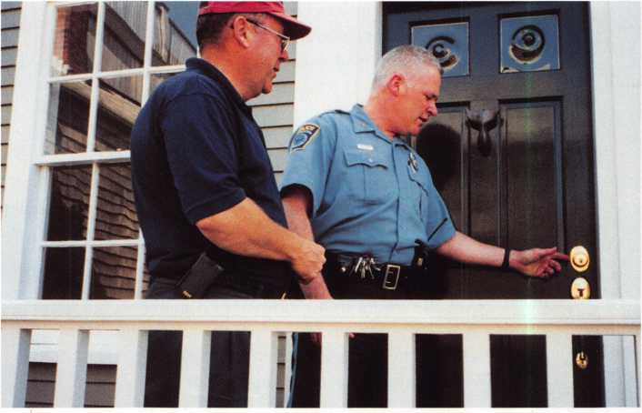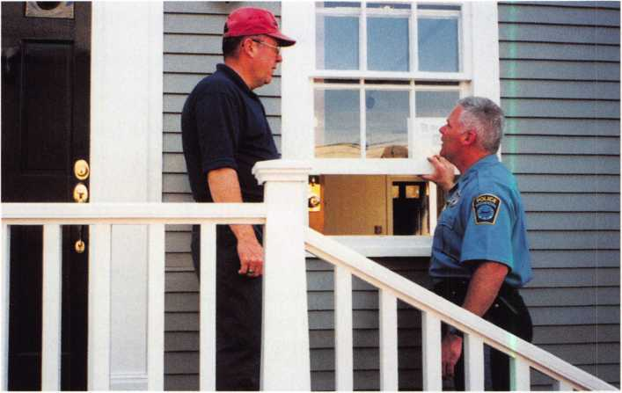

September 1999

Keynotes



We immediately report

all SUSPICIOUS PERSONS and activities to our Police Dept.

HOME

SECURITY

Community Service

To Your Neighbors

By Michael Ferrill

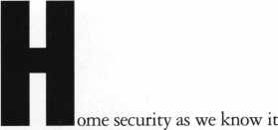

today could be as simple as locking your door when you leave your home, or turning on your multi million dollar, state-of-the-art security system, as you leave with your family on that much needed vacation.

Simply stated, home security involves your particular level of comfort and how safe you feel in your world. It also involves you the locksmith and your ability to provide that comfort of safety to your neighbors, friends, and working associates.

The average person looks to their locksmith as that person capable of providing technical and practical hands-on expertise in numerous security related fields. The young couple with small children in a middle class residential neighborhood, to the older couple in a high rise apartment building in New York City, depend upon their locksmith to protect them by recommending to them the best home security systems available on the market today. They also accept his or her trust and guidance in the affordability of these devices to meet their individual needs and their limited budget. Now comes the real challenge to the locksmith. How can I protect this family, friend or co worker and make his or her home safe and secure?

The first thing you should do, upon arrival, entering anyone’s home is to assess the current home security of the customer.

It’s one thing to get right to the job, it’s another to offer a free home security inspection to the homeowner before you start the job. If you show genuine concern for the safety and well being of his or her family you have won the respect and admiration of the home owner for your professionalism. If you’re just there to make a buck, the home owner will pick up on that aspect of your professionalism as well.

I always start my job with a warm intro­duction, upon arrival to the job site by saying “Hello my name is Mike Ferrill. I’m the locksmith that you called. Thank you for the opportunity to be of service to your family today. Before I start the work that you ordered for me to do today, could I provide you a free home security inspection?” The answer is always “yes” from the home owner. Like most locksmiths across the country and throughout the world I have come up with a reasonable home security checklist. The checklist is attached as an enclosure.

Another important resource that is available and free to the homeowner and residential customer is the local Police Department. Too often, locksmiths assume they are the only security experts for our

'ey notes

September 1999

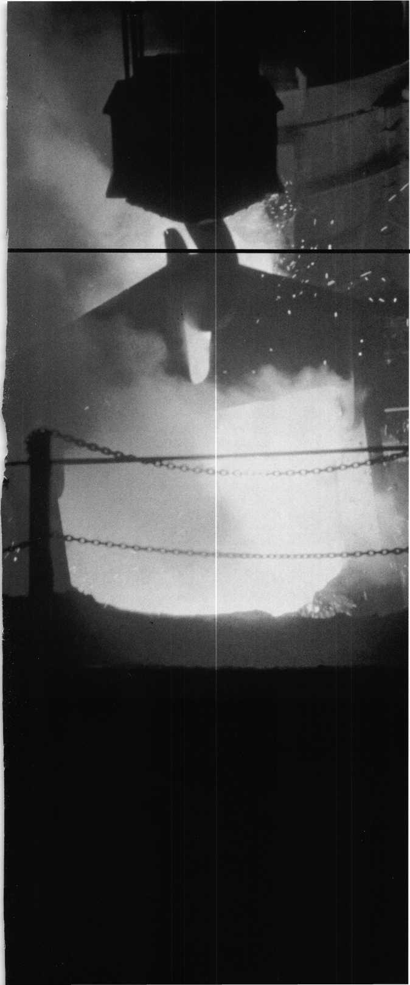

Have a blast.

Time to gear up for the last safe and vault event of the millennium—SAFETECH 2000! This year promises to be the hottest show ever, with experts on hand to answer questions, give demonstrations, and offer training in every area. With over 24 conveniently scheduled classes, and many exhibitors, SAFETECH 2000 is your source for the information and skills you need to take your career into the next millennium.

While you're there you can also enjoy the city known for its industriousness, as well as good oT Southern hospitality. Tour the Sloss Furnaces, which earned the town the moniker "Iron City;" visit the Mercedes Benz factory or any of a number of museums; or explore the richly wooded foothills and mysterious caverns of the Appalachian Mountains .

Join us May 1 through 6  
for SAFETECH 2000.

For more information call

214.827.7233,

or visit our website at

[www.savta.org](http://www.savta.org)



SAFETECH2000  
WE'VE GOT THE WORKS

Applicants

For Membership

Dept

*The following applicants are scheduled for clearance as members of ALOA. The names are published for member review and comment prior to October 1, 1999, respectively, to ensure applicants meet standards of ALOA’s Code of Ethics. Protests, if any, should be addressed to the Membership Department and must be signed. Active Membership applicants (A) have worked in the industry two or more years. Allied Membership (ALJ applicants are not locksmiths, but work in a security-related field. Apprentice Membership (AP) applicants have worked in the industry less than two years. A*

Clearing October 1:

USA

ALABAMA

Dothan

Lloyd E. Willits, A

ARIZONA

Chandle

William S Prosek, A SPONSOR: Enrique Olivares

Mesa

Frank Maldonado, AP SPONSOR: William Lee

Phoenix

Joel E Kennedy, A SPONSOR: William Lee

Tempe

Kee Tang, A

CALIFORNIA

Garberville

Don J Orazem, AP SPONSOR: Timothy Wallace

San Francisco

John H White, AP

Van Nuys

Corey J Friedman, A SPONSOR: Norman Weisenburger

FLORIDA

Miami

Camell C Brown, A

ILLINOIS Oak Lawn

Patrick J Orr, A SPONSOR: James Rackelin

INDIANA

Hammond

Sherman L Day, A SPONSOR: Daniel Enriquez

Indianapolis

David J Been, A SPONSOR: John Greenan

Michael L Curts, A SPONSOR: Jim Williams James Kardeke, A SPONSOR: John Greenan Jason Kritz, A SPONSOR: John Greenan Darrin Roland, A SPONSOR: John Greenan

Richland

Walter H Shaw, A

MASSACHUSETTS Fall River

Elden DaSilva, A SPONSOR: Peter Hammond

MARYLAND

Columbia

Raphael D Runion, A SPONSOR: Robert DeWeese

MICHIGAN

Hamtramck

Ben Heath, A

Redford

Bruce A McCan, AP SPONSOR: Robert Massard

MINNESOTA

Minniapolis

Kevin Tesmar, AP SPONSOR: Charles Cole

NORTH CAROLINA Wake Forest

Robert M O'Kelley, AP **Waxhaw**

Janice C Hunter, AP SPONSOR: Candice Hunter

NEW MEXICO Albuquerque

Eric E Hamman, A NEW YORK

New York

Russell R Halloran, A SPONSOR: Ronald Bartash

OHIO

Canton

Jeffrey D Roland, A SPONSOR: Michael Potter

Cincinnati

Joel E Carey, AP SPONSOR: James Brickler Dennis M Wilson, A

Mason

Randall J Heinlein, A SPONSOR: James Brickler

Parma

Vincent Lia, AP Robert Roslaniec, A

PENNSYLVANIA

Jenkintown

Charles D Wilson, A SPONSOR: Paul Wilson

TEXAS

Houston

Julias L Rodriguez, A SPONSOR: Richard Day

Lubbock

029140, William N Carrell, A

VIRGINIA

Fairfax

Jason E Adkins, AP SPONSOR: Anthony Bishop

Manassas

Boris L Ferrell, A

Yorktown

Leslie V Loftus, AP

WISCONSIN

Madison

Dale J Thompson, AP SPONSOR: Michael Stilwell

Prescott

Cheryl D Ristow, AP SPONSOR: Richard Ristow

WYOMING

Cody

Darin M McFarland, AP J McCumber

CANADA

ONTARIO

Mississauga

Max Cedri, A

CHINA

Beijing

Gong-Jiang Cheng, A

JAPAN

Itahashi-Ku

Nobuhiro Kawashima, A SPONSOR: Tadashige Tani

Naka-ku Yokohama

Kazuyoshi Shimazu, A SPONSOR: Toshihiro Asano

Urawa-City Saitama

Shigemi Shibata, A SPONSOR: Toshihiro Asano

Yokohamo Kanagawa

Makoto Sugowara, A SPONSOR: Keizo Takahashi

KOREA

Kwang-Ju-Gun

Nam Dong, A SPONSOR: Man Seo

UNITED

KINGDOM

Birmingham

James Jones, A

St Helens-Merseyside

James G Eckersall, A SPONSOR: Anthony Clare

W. Borough N. Hantz

Ken Dale, A

WEST INDIES

St George's Grenada

Findley J Gill, A

ALOA HAS  
FAXON  
DEMAND!

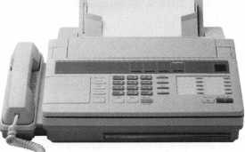

NEED INFORMATION

IN A HURRY?

Just call 310.575.5074  
and you will be faxed:

#1 A list of all documents available through this service #2 Becoming A Locksmith #3 Locksmith Career Summary #4 Locksmith School List #5 ACE Class Schedule #6 Certification Information #7 PRP Category List #8 ALOA Membership Application #9 ALOA List of Benefits #10 Scholarship Application Form #11 ALOA Video Library Order Form #12 ALOA Membership Items Order Form #13 Safe & Vault Technicians Association Member Application/Subscription Form #14 ALOA Chapter Roster #15 Legislative Action Network #16 Legislative Action Network Newsletters #17 Various State Laws #18 Industry Position Paper

YOUR ASSOCIATION  
CONTINUES TO EXPLORE  
WAYS TO PROVIDE YOU,  
OUR MEMBERS,  
WITH NEW BENEFITS  
AND SERVICES.

Keynotes

September 1999



ready to receive the screw. To make sure the inserts are installed properly, Heli-Coil manufactures a complete line of related taps and gauges, as well as hand, power and automated inserting tools and equipment.

Emhart Fastening Teknologies 510 River Road Shelton, Conn 06484 [www.emhart.com](http://www.emhart.com)

Gator Tools, Inc.

Gator tools is manufacturing a new innovative tool to remove and replace automotive face caps. The Multi-purpose Face Cap Tool, will remove a face cap from the lock housing with very minimal damage and the same face cap can be reused after the repairs have been made to the lock. This tool has a specially designed hardened tip and saddle and is fully adjustable to accommodate most any size of face caps. It requires a minimum amount of adjusting to give a profes­sional look after reinstallation of the face cap. The Multi-purpose Face Cap Tool is a hearty tool with a durable finish to resist weather. The installed torsion spring helps open the tool, making the tool a breeze to use. The tip is made of hardened material for long wear, but if broken can be replaced. It comes with a limited warranty. **Gator Tools, Inc.**

5030 Filarees Circle

Colorado Springs, CO 80917-1321

(719)591-8343

(719) 550-0953 fax

Secuvitron Magnalock Corp.

Securitron Magnalock Corp., has introduced the first package designed to meet national code requirements regarding the use of motion sensors for electric lock release. The XM-1 package combines Securitron s XMS-Exit Motion Sensor and your choice of one of its EEB series emergency exit buttons. The XMS will sense a person approaching within five feet of the door, automatically releasing the electromagnetic lock. The XMS is easy to install and to adjust with the sensing field easily directed to only unlock when it is supposed to. The EEB series buttons come in two models. The EEB-2 is a two-inch button mounted on a single-gang sized stainless steel plate while the EEB-3N comes with a 3/4" x 1" button in an 1-3/4" narrow style stainless steel mounting plate suitable for installation on door frames. Both models come with an integrated fixed 30-second timer and the compliant “Push to Exit” message.

Securitron Magnalock Corp.

50 Vista Blvd.

Sparks, NV 89434 (775) 355-5625 (800) Maglock [www.secritm.com](http://www.secritm.com)

Ingersoll-Rand Company

Von Duprin introduces a series of recessed exit devices. The design is available in different finishes, with a broad range of features and options that includes electric latch retraction and two-point or single-point LBR latching. The recessed configuration is well-suited to applications that must meet dear-width requirements for cross­corridor doors. The new INPACT exit device is available with smooth pushpads, designated as Series 9447, or with grooved pushpads, designated as Series 9547 devices. Both are concealed vertical rod devices. They replace the previous Series 9247 devices. The devices are available in seven colors, including polished and brushed chrome, polished and brushed brass, Duranodic, aluminum and dull bronze. Durable die cast aluminum end caps are available in standard black as well as optional matching or contrasting finishes. INACT is easy to install, with six mounting fasteners needed to mount the mechanism and pushpad in place. The end caps are then

fastened with 3-1/2" stainless steel fasteners to ensure alignment.

These mounting screws are recessed inside the door where they cannot be seen during normal operation.

Von Duprin Division Ingersoll-Rand Company 2720 Tohey Drive Indianapolis, IN 46219 (317) 897-9944 (317) 899-9302fax

Corby Industries, Inc.

Corby Industries Inc. has released the 6500 Series Programmable Keypads. The keypads are available in 11 different styles including indoor, outdoor, heavy-duty, spy-proof and parking lot models. These keypads provide an array of sophisticated access control features. Operating at 12 or 24 VDC a door (or other relay controlled device) can be activated for up to 165 users, it can be programmed from the keypad, using a three to six digit code. To simplify programming, an optional hand-held programmer and Windows-based programming software is also available.

Corby Industries, Inc.

1501 E. Pennsylvania St.

Allentown, PA 18103 (610) 433-1412

LAGARD, Inc.

LA GARD Inc. has announced the introduction of an electronic lock at a mechanical lock price. The LG Basic was developed to present an electronic lock at a price that is comparable to mechanical locks, while maintaining the reliability and security of a high end electronic lock. The LG Basic is equipped with a non-volatile memory, it will not lose its combination if the battery is discon­nected or suffers a power loss. It is powered by a 9-volt alkaline battery and includes a warning signal when the battery is running low. Another feature includes the “wrong try penalty.” This feature engages when a person enters the wrong combination after a certain number of times. This will activate the time penalty and not allow the user to operate the lock until the penalty period has expired. For more information about the LG Basic, call LA GARD s 24-hour Fax-On-Demand request line (877) LAGARD2 or 524-2732.

LA GARD Inc.

3330 Kashiwa Street Torrance, CA 90505 (310) 325-5670

ID Systems

ID Systems a manufacturer of Electronic Article Surveillance (EAS) Ant-Shoplifting systems for retailers, introduces the EM MINI Label, a small (1 1/4" x 3/4") Electromagnetic security label to protect small pocketable items. The tiny, easy to apply label replaces the standard security strip. The new smaller size is ideal for securing any small items such as cigarette cartons, cosmetics, jewelry, CDs, etc. The EM MINI Label can be quickly applied to products using a standard label dispenser. Pricing information can easily be imprinted on the plain white paper top surface. ID Systems full line of EM detection systems including the EM DSP, EM 1300 and Ellipse can detect the new EM MINI Label without software modifications.

ID Systems

37 Voyager Court

North Toronto, Ontario M9W 4Y2

(416) 674-4788

(416) 674-5075 fax

[www.idsystems-dialoc.com](http://www.idsystems-dialoc.com)

***Keynotes* | 11**

September **1999**

**Security**

Marketplace

Olympus Lock, Inc.

Olympus Lock announces the addition of two patented products to its line of pin tumbler cabinet locks. The new Olympus 850SC and 950IC series deadlocking latch cabinet drawer locks combine increased security with the convenience of a latch lock. The Olympus 850SC ships standard with Schlage C keyway and includes the patented set screw technology for easy rekeying. Lori conversion plugs may be used to key into other systems and the lock will accept other manufacturers’ cylinders. The Olympus 950IC accepts Arrow, Best, Falcon, KSP or equivalent interchangeable cores and is sold less core. The Olympus 850SC and 950IC locks will retrofit any 1-1/8" diameter cabinet lock and use the same footprint as Olympus Lock’s #700SC, #800SC, or #721 cabinet locks. These items may be purchased in either US26D or US3 finishes.

Olympus Lock (800) 525-0954

Marks USA

Marks USA has developed an ANSI grade one tubular deadlatch. This product was created by modifying its grade one tubular deadbolt components to accommodate a new heavy duty, grade one tubular latchbolt. The latchbolt features a stainless steel deadlocking latch nose with a 9/16" latch throw. This allows installation for a tubular deadlatch, which is available in both conventional as well as IC core cylinder models.

Marks U.S.A.

5300 New Horizons Blvd., Dept. K-6 Amityville, NY 11701 (516)225-5400 (516) 225-6136fax

Glowrite U.S A

Glowrite is manufacturing a product called Glowholes. Glowholes are glow in the dark keyholes that have a powerful glow and are charged by natural light. The Glowholes are stickers with a long lasting superb adhesive. They charge fully in natural light in about four hours. They glow for approximately 13 hours with a full charge. Glowholes come in two parts, the outside ring and the inside keyhole cap. They fit doorknobs, deadbolts, padlocks and standard automotive keyholes.

Glowrite U.S.A.

(877) 724-0228 tvww.glowrite.com

Light Technology, Inc.

Light Technology introduces a state-of-the-art miniature flashlight that has no conventional light bulb. Instead of using a bulb, the 3 inch long flashlight uses a white light emitting diode (LED). The PAL Survival Light weighs less than three ounces yet throws an intense beam of almost pure white light. It features four distinct light modes: low beam, high beam, emergency flashing strobe light and a standby mode. The standby mode provides a pilot light that remains illuminated even while the switch is off, this permits it to be found in a darkened area. The PAL Survival Light’s standard 9 volt battery will last 10 times as long as batteries in a standard flashlight because it uses a built in proprietary micro-circuitry to regulate power consumption. The flashlight is moisture and shock



resistant with its internal electronics encapsulated to protect it from the elements. In addition to its many consumer applications, physicians and dentists have also found the light useful. The clear, true white light does not discolor human tissue making it valuable as a diagnostic aid.

Light Technology, Inc.

571 Interstate Blvd.

Sarasota, FL 34240 (941) 377-7445 tvtvw.lightechnology.com

Secura Key

Secura Key announces the Radio Key RK-WS Proximity Reader. The Radio Key RK-WS is the newest reader in the Radio Key family of proximity products, which is designed to integrate into any system requiring a Wiegand output. The reader will read Secura Key proximity cards or key tags and transmit the data in virtually any Wiegand Format up to 40 bits. The reader measures less than 4 1/2" x 3 1/4" and has read distances up to 8". The unit is completely potted and is rated for extreme weather and vandal resistance. Includes a bi-color LED and buzzer control. Installation is easy. Two screws mount the unit to a single-gang electrical box, masonry wall, post or almost any surface.

Secura Key (877) 868-2422 (818) 882-0020 [email@securakey.com](mailto:email@securakey.com) [www.securakey.com](http://www.securakey.com)

Pelco

Pelco introduces its MCSE Series indoor power supply, which offers a variety of configurations for powering up to 16 devices from a single power source. This series provides 24 VAC output for 4, 8, or 16 cameras and supports 120 VAC input power. These units are all packaged in an easy-to-install metal enclosure that offers ample room for wiring connections and conduit entries. Models come with input and output fuses, including spares, to provide a high degree of protection from the camera. For integrated systems such as Spectra and Esprit (tm), the higher capacity models can handle pan/tilt and receiver operation in addition to the camera. Pelco 300 West Pontiac Way Clovis, CA 93612-5699 (800) 289-9100

Emhart Industrial Heli-Coil Products introduces self-tapping wood inserts to provide flexibility. The Self-Tapping Wood insert is a helically-wound coil of carbon steel wire, formed to a diamond­shaped cross section. Knife-like threads on the outside of the coil give maximum penetration then tapped into the wood fibers, leaving thick sections of wood between the threads for maximum strength. The easy-to-install Self-Tapping Wood Inserts offer a versatile and inexpensive method for making stronger threads in wood and other fibrous materials. This brings a greater design flexibility to furniture manufacturers, the wire screw thread fasteners allow thread-wear protection and stronger-than-ever joints in both face and end-grain installations. Installing the Self-Tapping Wood Insert involves simultaneous countersinking and inserting the insert into a pre­drilled hole. When the insert taps itself to the proper depth-1/2 to 1 turn below the work surface-the mandrel is reversed and unscrewed from the installed insert. The hole, threaded by the insert, is then

***Keynotes***

September 1999

|  |  |  |
| --- | --- | --- |
| 2000 | MAY | JULY |
| FEBRUARY | 1-6 | 16-22 |
| 13 | SAFETECH 2000 | ALOA 2001 Security Expo |
| f/f ALOA PRP Sitting | Birmingham, AL | Baltimore, MD |
| Houston, TX | (214) 827-7233 | (800) 532-2562 |
| The Texas Locksmiths Association | | |
| Contact: Judy Clifford | JULY | 2002 |
| (409) 297-2413 | 24-30 |
| (409)297-1483 fax | ALOA 2000 | JULY |
| APRIL | Las Vegas, NV (214) 827-1701 | 22-28  ALOA 2002 Security Expo |
| 2001 | Rosemont, IL |
| 6-9  Ace Classes | MARCH | (800) 532-2562 |
| MLANJ 2000 | 28-April 1 |  |
| Annual Convention | MLANJ 2001  Annual Convention |  |
| Somerset, NJ | Somerset, NJ |  |
| (973) 267-8884 | (973) 267-8884 |  |
| (973) 538-2248 fax | (973) 538-2248 fax |  |
| [www.mlanj.org](http://www.mlanj.org) | [www.mlanj.org](http://www.mlanj.org) |  |

Indicates ALOA ACE Class  
**fj?** Indicates PRP Sitting

**Yankee Security Conference And Trade Show**

**November 6-10, 1999**

'X\ I

**LOCATION: Sturbridge Host Hotel, 366 Main St., Sturbridge, MA 01566**

**TRADE SHOW: November 6-7, 1999**

**CLASSES: November 8-10, 1999**

* **A.L.O.A, A.C.E. certified instructors**
* **Many new and innovative classes**
* **The industry's top manufacturers, distributors and manufacturers' representatives**
* **For more information, visit us on the web at [www.yankeeconvention.com](http://www.yankeeconvention.com)**

September 1999

Keynotes L

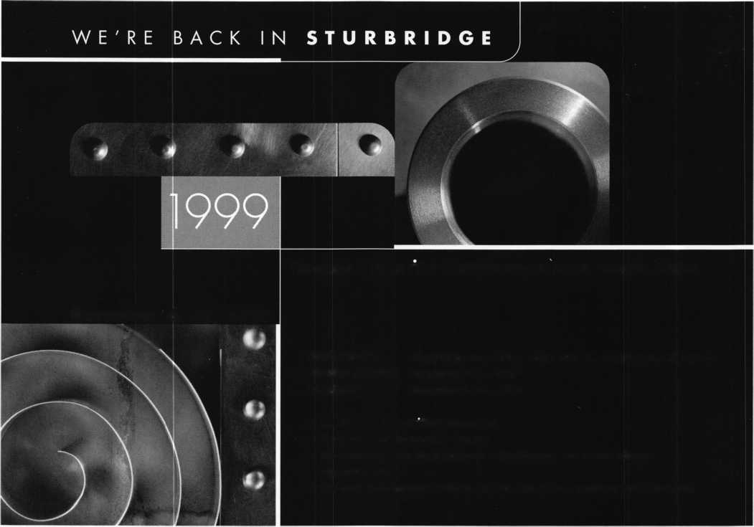

Upcoming

Events



Dept

SEPTEMBER

11

^ ALOA PRP Sitting Dallas, TX

Contact: David Lowell (800) 532-2562

1. 827-1810 fax

15-19

GPLA Annual Convention

Philadelphia, PA

Jack Magee (registration)

1. 845-3434

Don Amole (booth space)

1. 288-5588 [www.gpla.org](http://www.gpla.org)
2. 19

TAOL’s 26th Anniversary Convention International Plaza Hotel and Conference Centre Toronto, Ontario (888)272-8265 (416) 321-5115 fax

1. 19

Ozark Professional Locksmith Assoc. Distributors Show Inn of the Ozarks,

Eureka Springs, AR Betty Gray: (501) 524-3660 day (918) 427-1066 evenings or Bill or Janis Reves (501)631-0017 day (501) 631-6406 evenings

19

ALOA PRP Sitting Philadelphia, PA

Greater Phil. Locksmiths Association Contact: Bill Young, CML

1. 647-5042 (610) 647-5950 fax

25

**£r\** ACE Classes Casper, WY

Wyoming Locksmiths Association Contact: Gene Ficek, CPL (605)642-4542

26

ALOA PRP Sitting Casper, WY

Wyoming Locksmiths Association Contact: Gene Ficek, CPL (605) 642-4542 (605) 642-8946 fax

30 - Oct 1

**fcr\** ACE Classes Baton Rouge, LA

LOU-MISS Locksmiths Association Contact: Tommy Hunt, CPL, CPS (205)833-3333 (205) 836-3333 fax

30-Oct 2

MINK Convention Marshalltown, LA Iowa Locksmith Association Contact: Kenneth Novey (319)377-4295

OCTOBER

1-3

Jo-Van National Trade Show and Educational Seminar Contact: Ron Wilson (416) 752-7249

3

10th Annual Locksmith Flea Market/Swap Meet Hayward, CA

SF California Locksmiths Association Contact: Blaine Lucas, CML (510) 278-2583

9

**&** ALOA PRP Sitting

ALOA

Dallas, TX

Contact: David Lowell (800) 532-2562 (214) 827-1810 fax

10

**^** ALOA PRP Sitting Burbank, CA Clark Security Products Contact: Terri Burges (619) 974-5273 (619) 974-5284 fax

16-17

Professional Safe Moving Class Eau Claire WI

Indian Head Chapter of ALOA Contact: John Dorsey (715)832-4207

16-18

DHI 24th Annual Convention and

Exposition

Dallas, TX

Contact: DHI

(703) 222-2010

16

ALOA PRP Sitting Richmond, VA

Virginia Locksmiths Association Contact: RT Earll, CML (703) 368-0595 (703) 335-0852 fax

17

**fk** ALOA PRP Sitting Largo, MD

Institutional Locksmiths Association Contact: Philip A Rovenolt (301) 645-7786 (202) 645-6530

17

**fk** ALOA PRP Sitting Coraopolis, PA Penn/Ohio Locksmith Assoc. Contact: Martha R. Eggler

1. 676-8464 (216) 267-2511 fax

24

**fcr\** ACE Classes St. Louis, MO

Gateway Locksmiths Association Contact: Paul Skoulby (314)423-3720 (314)423-3720 fax

29-31

Convention

Basildon, London

Master Locksmiths Association

London Region

Contact: D. Stokes

0181-520-7450

0181-521-8376 fax

[MLA_LR@hotmail.com](mailto:MLA_LR@hotmail.com)

NOVEMBER

8-10

**fcsA** ACE Classes **fk** ALOA PRP Sitting 1999 Yankee Security Convention Sturbridge Host Hotel Sturbridge, MA Rob Mahoney (800) 209-8266

13

**fk** ALOA PRP Sitting

ALOA

Dallas, TX

Contact: David Lowell (800) 532-2562 (214) 827-1810 fax

20

ACE Classes Oklahoma City, OK Oklahoma Master Locksmiths Associa­tion

Contact: Lowell Roberts (405)732-5838 (405) 741-5838 fax

DECEMBER

ii

**$k** ALOA PRP Sitting

ALOA

Dallas, TX

Contact: David Lowell (800) 532-2562 (214) 827-1810 fax

-J

**ii** Keynotes

September 1999

core



Keynotes bids farewell to John Kerr

Former ALOA president and  
longtime member W. John  
Kerr passed away June 25 at his  
home in Portland, Ore. He was  
69 years old.

John served as ALOA’s  
president from 1979 to 1981 and  
was active in various committees  
and offices within the association.

He also served as president of the  
Pacific Locksmith Association and  
was recently Educational  
Chairman for the 25 th Annual  
Tri-Regional Locksmith  
Conference in 1998.

Among his numerous business ventures were Atlasta Lock Co., which he founded and co-owned. In 1986, he sold that business to start Low Tech products where he pursued his goals of inventing and patenting locksmith products.

Among John’s hobbies were fly fishing and game hunting. In fact, he was working on a book, The Lighter Side of Deer Hunting before he died.

John is survived by his wife of 40 years, Shirley Ann Kerr.

Donations can be made in John Kerr’s name to ALOA’s Scholarship Fund at 3003 Live Oak Dallas, Texas 75204. Just recently, John’s comrades at the Pacific Locksmith Association made a contribution of $500 in his name.

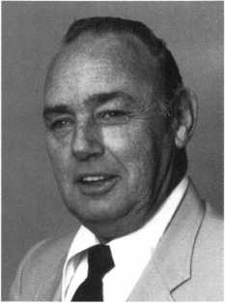

• Early Bird Gets The Worm!

Congratulations to Mark A Keown! Mark was the winner of a Full Convention Registration Package for the ALOA 2000 Convention and Security Expo to be held in Las Vegas, Nevada, July 24-30, 2000. Mark was one of many whose names were entered into a drawing for registering for ALOA ’99 by June 28.

• New Leadership

The South Jersey Locksmiths Association recently elected new officers, the positions are as follows:

President- Paul L. Palmisano, CRL Vice President-Richard R. Olive Secretary-John N. McCleery Treasurer-Fred R. Steinman Sergeant at Arms-Marvin Weinstein

PRP

CRLs

James Baker, Chicago, IL Jerome S. Lord, Houston, TX Darrel W. Moore, Humble, TX



• Obituaries

Gary Glover,

CML, 58 of Fresno,  
CA was recently killed  
in an automobile  
accident. Gary was a  
member of ALOA for  
over 33 years and  
served as an ACE  
instructor. Many of us  
had the opportunity to  
meet and know Gary  
while attending

Gary Glover taught classes at ALOA ’99 in Cincinnati.

ALOA ’99 in  
Cincinnati. He will be

sorely missed as an instructor as well as a friend.

Keynotes and ALOA would like to offer our condolences to the  
friends and family of Gerry Finch. Gerry passed away in April after  
a bout with throat cancer.

A writer and instructor, Gerry was known for his instructional  
books and courses that centered on picking, master keying and inter-  
changeable core cylinders. These days, most industry professionals  
look to his interchangeable core manuals as primary reference  
materials.

Among the awards he received during his long career were the  
California Locksmith Association’s Golden Key Award, the ALOA  
President’s Award, the Lee Rognon Award, the Gerald Connelly  
Pioneer award and the Philadelphia Award.

As a security professional, Gerry served in the Air Force and  
instructed at the U.S. Army Technical Intelligence Center in Baltimore,  
where he instructed the Defense Against Methods of Entry course.

He also served as a technical consultant with the Hori Lock  
Company, in Tokyo, Japan, General Manager of Keying and Security  
for the Weisner/Falcon Company and Product Design Manager of  
Lab Security.

We must also say good-bye to M. Hugh Little, 80 of Troutdale,  
OR. Hugh was a member of ALOA for over 17 years.



September 1999

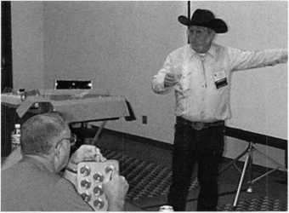

Keynotes

I WAVE GOODBYE

ALOA would like to offer  
special thanks to everyone  
who helped make ALOA ’99  
in Cincinnati a success!

First off, we’d like to thank  
the members, volunteers and  
exhibitors who attended.  
Your attendance helped make  
this show fun and informative.

We would also like to extend a special thanks to our sponsors! Their support was instrumental in the development and coordination of this great event.

mni<l|MASTER KEY SPONSORS

mum

**MASTER KEY SPONSORS**

SCHLAGE

YALE SECURITY, INC.

**CHANGE KEY SPONSORS**

AT&T PROFIT BY ASSOCIATION SECURITY LOCK DISTRIBUTORS

The Brightest And The Best

Walter Lascar, RL

Thomas Vandersteen, CML

William Grant, CRL

Gary Teams, CPL

|  |  |  |
| --- | --- | --- |
| 175 | Kwok-kei Leung |  |
| 94 | Toshihiro Asano |  |
| 93 | Henry Raymond | ■If |
| 66 | Stewart Levine, CML |  |
| 65 | Charles Robertson, CML |  |
| 64 | Mary Ohmit, CPL |  |
| 61 | Yuriko Yanai |  |
| 51 | Jack Hobin, CPL |  |
| 48 | Allen Konrath |  |
| 40 | Salvatore Dulcamaro, CML |  |
| 38 | Myeong-Rae Cho |  |
| 36 | William Neff, CML |  |
| 33 | David Lowell, CML | 15 |
| 32 | Thomas Freehling, CML | 15 |
| 31 | Dana Barnum, CML | 15 |
| 31 | John Heckman, CML | 15 |
| 30 | Jeanne Lodge, CML | 15 |
| 28 | Barry Leas, CRL | 15 |
| 26 | J Thomas Hood, CML | 14 |
| 24 | .Lawrence F. Smith, Jr., CML | 14 |
| 24 | Danny Rudd, CPL | 14 |
| 24 | John Elliott, CML | 14 |
| 24 | Larry Warnick, CML | 14 |
| 24 | Roy Renderer, CML | 13 |
| 23 | James Watt, CML | 13 |
| 23 | Robert Carroll, CPL | 13 |
| 23 | Robert DeWeese, CPL | 13 |
| 23 | Jim Williams | 13 |
| 22 | Diana Barnum, CRL | 13 |
| 22 | Barbara Watt | 13 |
| 21 | Anthony Ramunno, CML | 13 |
| 21 | Jerome Cohen, CML | 12 |
| 21 | David M A Federico | 12 |
| 21 | Eugene Altobella | 12 |
| 20 | Charles Cole, CML | 12 |
| 20 | Elvis Hammerschmidt, CPL | 12 |
| 20 | William Lee | 12 |
| 19 | Marian Swann, CRL | 12 |
| 18 | John Dorsey, CPL | 11 |
| 18 | D Michael Lee, CPL | 11 |
| 18 | James Fowler, CML | 11 |
| 18 | David Harris, CML | 11 |
| 17 | John Kerr, RL | 10 |
| 17 | Keizo Takahashi, CRL | 10 |
| 17 | Ronald Heidzig | 10 |
| 17 | Philip Rovenolt, CPL | 10 |
| 16 | Joseph Ferrero, CML | 10 |
| 16 | James Cawby, CML | 10 |
| 16 | Michael Robinson, CRL | 10 |
| 16 | Brian Reetz | 10 |

Richard Sievers

Joe Lee, CRL

Steven Spiwak, CRL

Robert Rodocker, CRL

Keiryu Tsukishiro, CRL

Rolando Bouza

Lonnie McKinney, CML

John Engel, CRL

Donald Shiles

Eric Veal

Herbert Dusenberry, CML

Raymond Lusk, CML

Robin Horsley

Michael Groves

Thomas Demont, CML

Ernest Wright

_William Wickward, CML

Lester Brodsky

Joseph Whitaker, CPL

Dale Knowles, CPL

John Ilk, CRL

James Hawley, CRL

.William McElheney, CML  
Russell Fuller, CRL

Rex Parmelee, RL

James Gruber, CRL

Robert Duman, CML

James Brickler, CRL

Daniel Landry

Edwin W Scott

_Peter Gauthier, CPL .Frank Hartung, CML Jon Griswold, CML Paul Souber

How can I join the President's Club?

You can earn membership in this prestigious club by recruiting just 10 new members for ALOA.

*Any ALOA member may participate.

What do I get?

When you recruit 10 members, you receive a handsome blue blazer with a President's Club crest. For each additional five members you recruit, you receive a lapel pin with gold-filled numbers, indicating your recruiting successes.

You also get the satisfaction of knowing that you are helping your association, helping your industry grow, and you are helping fellow locksmiths achieve success.

How do I get started?

Contact the ALOA office for a supply of applications (800) 532-ALOA or FAX (214) 827-1810. One President's Club credit is awarded for each new applicant. Credit is awarded only after the membership application is approved. However, the credit will apply for the period in which the application is received. Failure to identify yourself as the sponsor on the application form at the time it is submitted to ALOA for processing will forfeit any credit.

*ALOA Board of Directors not eligible for membership in the President's Club.

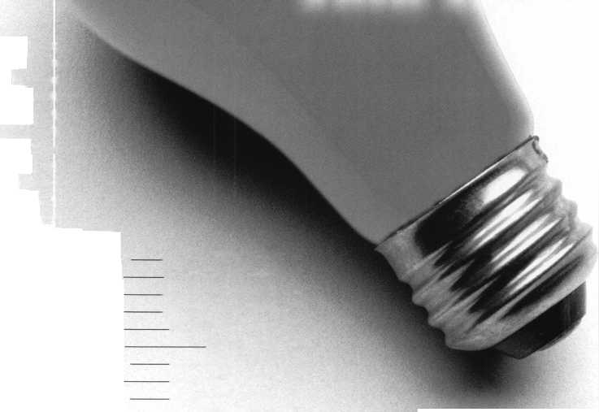

with John Greenan

Reflections on this year’s election and on ALOA ’99

3

O

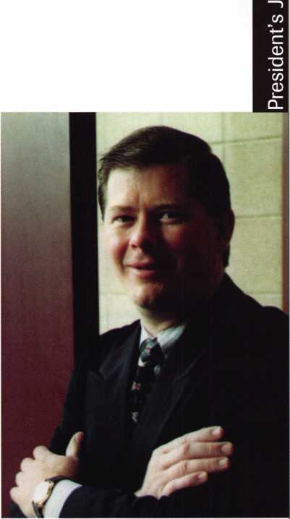

As I write this (my first ever column as ALOA President), ALOA ’99 has come and gone. If  
you were there, you know it was no doubt one of our best shows and a fitting end to ALOA  
conventions in the 20th century.

Before I discuss how well the convention went, I’d like to take this opportunity to thank the  
members who participated in the election. Although both Jim Glazier and I were disappointed  
in the number of members who voted, we hope to see more participation in the future. We  
realize that putting the ballots in the magazine may have had some effect on the number of  
ballots received and we are working on correcting that problem for future elections.

Also, congratulations to Jim Glazier on a well-run campaign. He’s a vital part of our industry,  
instructing many classes and writing some of the best articles on CCTV in the industry. Jim will  
still be serving as a Northeast Director on the ALOA board and I look forward to working with  
him in this capacity.

I also extend my thanks to past presidents Dallas Brooks and David Lowell, who worked  
diligently to make the changes to our association that will help us to be successful in the coming  
years. They have made my job much easier although I am not looking forward to trying to fill  
their shoes.

Fortunately, I was able to begin my new job as President at ALOA ’99 in Cincinnati. The city  
was a fine host and its Convention Center facilities provided us with ample resources to  
accommodate everyone’s needs.

Reflecting on this year’s show, I applaud our Education Department. As usual, it seemed to  
be in excellent form, coordinating classes, and staying on an extra day for the first-ever Bonus  
Sunday.

Of course, I’d also like to draw attention to this year’s membership meeting, which allowed  
everyone a chance to speak their mind on numerous topics ranging from dues to education to the  
PRP and more. It also allowed us to recognize our Life Members, the ACE Award Winner and  
Keynotes' Author of the Year.

This was a well-attended meeting, which was pleasing to say the least. Plus, there were many  
interesting points brought up and plenty of enthusiasm from the membership. Best of all, there  
was a tme sense of positivity in the air, which in my mind, signified unity within our association.

Among the other notable events was the first-ever Presidential Roundtable on Chapters and  
Regional Associations. Here, representatives from various chapters and associations were able to  
exchange ideas, update each other on state legislative issues and bring to light different facets of  
their respective organizations. (Editor’s note: See Legislative Update on p. 41 for further details).

Likewise, the State of the States Roundtable proved to be an insightful look at the differences  
in locksmith legislation around the country.

Another interesting aspect of this year’s show was the overwhelming number of international  
members who made the long journey to Cincinnati. Members from Japan, Korea, Denmark,  
Mexico and other countries could be spotted throughout the show. If anything, it’s a further  
indication of how rapidly ALOA’s influence is spreading throughout the world.

To all of those who were able to make it, I say, “Thank You.” To all of those who were unable  
to come this year, your presence was sorely missed. Remember, though, there’s always ALOA  
2000 in Las Vegas.

It’s events like these that make many of us proud to be an ALOA member. By the same token,  
seeing all the friendly faces at ALOA ’99 made me proud to serve as your new president.

I know that it will be a year before we can all meet again in Vegas, but if the Cincinnati show  
was any indication, it will surely be worth the wait!

If you you have any questions, comments or suggestions, please call, fax or email me:  
voice: (773) 486-2030, fax: (773) 486-3676, email: [fsl.john@mindspring.com](mailto:fsl.john@mindspring.com).

\

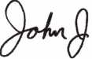

Keynotes

September 1999

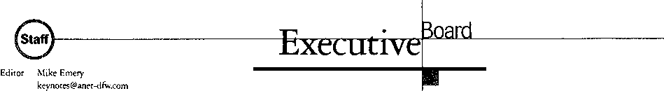

Technical Editor

Communications/Financial Coordinator Editorial Advisor

Advertising Sales

Contributing Editors

Contributing Authors

David Lowell, CML, CMS

[david@aloa.ioffice.com](mailto:david@aloa.ioffice.com)

Patanya Johnson

John D. Cannon, CML

[jdcannon@worldnet.att.net](mailto:jdcannon@worldnet.att.net)

Marvin Diamond

Native American Journal Co.

(706) 782-0878

[thediamonds@mindspring.com](mailto:thediamonds@mindspring.com)

Paul Chandler, CRL

Claire Cohen, CML

Sal Dulcamara, CML

Jerome V. Andrews, CML

Brian Costley, CML, CMS

Bob De Weese, CPL

Ray D’Adamo, CML

Michael A. Ferrill

James Glazier, CML

Daniel Graffeo, CRL, CMS

Wayne Gurnee, CRL

A.J. Hoffman, CML

Ken Holmlund, CRL

Ray Lusk, CML

Mark Ohno

Randy Simpson, CML

Robert Stafford, CPL

Dave Thielen, CML

Additional contact information for the ALOA Board and most Keynotes authors is available through “Locksmith Search”’ on the ALOA website- [www.aloa.org](http://www.aloa.org) or by contacting the ALOA office at 3003 Live Oak Street; Dallas, TX 75204; (800)532-2562; FAX (214)827-1810; e-mail [aloa@aloa.org](mailto:aloa@aloa.org).

President

John J. Greenan, CML. CPS (773) 486-2030

Secretaiy

John D. Cannon. CML (703) 960-6413

Directors, Northeast

James H. Glazier, CML (301) 831-5454 John C. Magee, III

1. 845-3434 William L. Young, CML
2. ) 647-5042

Directors, Southeast

Thomas W. Tate (850) 476-4211 Donald E. Rule, CML (601) 324-2658

Directors, North Central

Mark E. Blum, CML, CPS (517) 482-5809 Tom Ripp, CRL (608) 262-3831

Director, South Central

Randy L. Simpson, CML (713) 780-7026

ALOA Professional Staff

|  |  |  |
| --- | --- | --- |
| Executive Director | Charles W. Gibson, Jr., CAE [charlie@aloa.ioffice.com](mailto:charlie@aloa.ioffice.com) |  |
| Operations Manager | Mary May  [mary@aloa.ioffice.com](mailto:mary@aloa.ioffice.com) |  |
| Comptroller | Kathy J. Romo |  |
| Meetings Manager | Jessica Smith [jessica@aloa.ioffice.com](mailto:jessica@aloa.ioffice.com) |  |
| Meetings Assistant | Amy Sheffield |  |
| Government Affairs Manager | Tim McMullen [tim@aloa.ioffice.com](mailto:tim@aloa.ioffice.com) |  |
| PRP/Education Manager | David Lowell, CML, CMS [david@aloa.ioffice.com](mailto:david@aloa.ioffice.com) |  |
| PRP/Education Coordinator | Ashley Spencer |  |
| Membership Manager | Brandon Durrett [brandon@aloa.ioffice.com](mailto:brandon@aloa.ioffice.com) |  |
| Chapters & Regional |  |  |
| Associations Liaison | Tim McMullen  [tim@aloa.ioffice.com](mailto:tim@aloa.ioffice.com) |  |
| Information Systems Manager | Randy McChristian | im |
|  |  |  |

Directors, Southwest

Gordon R. Racine, CML (719) 384-4707 John A. Ilk, CRL (602) 420-2174

Director, Northwest

Scott L. Henke, CRL, CPS (907) 248-3785

Director, Associate Members

Judd Penske (800) 634-5465

Trustees

Dallas Brooks

(334) 826-8990

David M. Lowell. CML. CMS

(800) 532-2562

Breck H. Camp, CML

(770) 455-6244

Edwin Toepfer, RL

(416) 225-5589

Chairmen of International Affairs

Laurence P. Mills/Australia (129) 958-0445 Hans Mejlshede, CML/Europe FAX (453) 139-1004

Mission Statement: The Associated Locksmiths of America, Inc. is dedicated to enhancing the professionalism, education and ethics among locksmiths and those in related sectors of the physical security industry. With approximately 10,000 members in the United States, Canada and the freeworld, ALOA is poised to help members obtain the knowledge, the strength, and the confidence to perform their role in the physical security field with pride and dignity. But it is only through active involvement and participation that ALOA can fully achieve its potential-and can help members to achieve theirs.

Policies: Keynotes® is the official publication of the Associated Locksmiths of America, Inc. (ALOA). Keynoted acts as a moderator without approving, disapproving, or guaranteeing the validity or accuracy of any data, claim, or opinion appearing under a byline or obtained or quoted from an acknowledged source. The opinions expressed by the authors do not necessarily reflect the official views of ALOA. Also, appearance of advertisements and new products or service information does not constitute an endorsement of products or services featured by the Association. The Association does not accept responsibility for the inaccuracy of any data, claim, or opinion appearing in this publication, due to typographical errors on the part of the authors, Association staff or its agents. Editor’s Note: This publication is designed to provide accurate and authoritative information in regard to the subject matter covered. It is provided and disseminated with the understanding that the publisher is not engaged in rendering legal or other professional services. If legal advice and other expert assistance is required, the services of a competent professional should be sought.

Authors’ Payment: Payment for eligible submissions to Keynotes will be based on the following criteria: topic, time spent and past contributions. Authors who regularly submit to Keynotes are generally paid a higher rate. The latter is especially true of authors who write to fit specific editorial needs and submit said copy by Keynotes deadlines. As a general guideline: Average payment for a 750 word, business or ‘light’ technical article would be $200. Payment for a 1500 word article involving significantly higher time and research efforts would be $400.

Payment will not be offered for articles submitted by ALOA employees or members of the ALOA Board of Directors (unless material is of a technical nature), nor for articles submitted by a company that promote that company’s products or services. ALOA reserves the right not to pay for articles submitted by an individuals) that promote a particular company’s products or services.

Disclaimer: The Associated Locksmiths of America, Inc., (ALOA), reserves the right to refuse any article for any reason. Additionally, ALOA reserves the right to edit, amend or modify any article submitted for publication in order to preserve technical accuracy, clarity, fairness or grammatical correctness. ALOA will make the best efforts to notify the author of any changes. The extent of ALOA’s liability for any article or information contained therein will be a notice of correction or retraction in the next possible issue.

Keynotes® (ISSN 0277 0792) is published monthly except for the combined June/July issue by The Associated Locksmiths of America, Inc., 3003 Live Oak St., Dallas, TX 75204-6186. Telephone: (214) 827-1701; FAX (214) 827-1810; e-mail [aloa@aloa.org](mailto:aloa@aloa.org). Subscription rates for members-$15.00 per year. Second class postage paid at Dallas, Texas. POSTMASTER: Send address changes to: Keynotes, 3003 Live Oak St., Dallas, TX 75204-6186. © Copyright 1999, All rights reserved. No part of the contents may be reproduced or reprinted in any form without prior written permission of the publisher.

Past Presidents

1997-1999 Dallas C. Brooks 1995-1997 David Lowell, CML, CMS 1993-1995 Breck Camp, CML 1991-1993 Henry Printz, CML 1989-1991 Evelyn Wersonick, CML, CPS 1987-1989 Leonard Passarello, CPL 1985-1987 Joe Jackman, CML 1983-1985 Stanley Haney, CPL 1981-1983 Louis LaGreco, CPL 1979-1981 John Kerr, RL 1977-1979 Clifford Cox, CML 1974-1977 Charles Hetherington 1972-1974 Gene Laughridge 1970-1972 William Dutcher, RL 1968-1970 Constant Maffrey, RL 1966-1968 Harold Edelstein, RL 1964-1966 William Meacham 1962-1964 Robert Rackliffe, CPL 1960-1962 Edwin Toepfer, RL 1956-1960 Ernest Johannesen

September 1999

***Keynotes***

Conte

Sftptftmhftr

Features

4

President's Journey

The first column from new ALOA president, John Greenan. Reflections on this past election and on the recent convention.

By John Greenan, CML, CPS

14

Home Security:

Community Service To Your Neighbors

The Island Locksmith offers pointers on how locksmiths can learn from Crime Prevention officers, and vice versa.

By Michael Ferrill

22

Basics

A look at one of the security industry’s most intricate specialties.

By Greg Perry, CML, CMS

’99-The Way it Was!

If you were there, you know how great it was!

If you weren’t, here’s your chance your chance to get a peek at the convention that was ALOA ’99.

24

Locksmith Librarian

By Michael Ferrill

25

Crime Prevention: What Works

figures and hot opinions from a concerned

security professional

By Don Dennis, CPL

28

Security Technology and Privacy

It’s a fine balance between security and total freedom. Is it possible to have both?

By Sal Dulcamara, CML

32

Gambling On New Hire

A new employee can be an asset and a hindrance. Learn how to handle new hires and what to expect.

By George Sharpley, CML

The Cover

Next month is Crime Prevention Month.

This issue explores how security professionals can use their know-how to make a difference.

41

Legislative Update

A look back at some of the important meetings and events at ALOA ’99.

By Tim McMullen

Art direction/design Valerie Rowe



Keynotes

September 1999

7

Core

Upcoming Events

Security Marketplace

Applicants for Membership

Scheduled for clearance October 1

42

Authors in This Issue

44

Backpage

Just when you thought it was safe to read the back of the book...ANOTHER chance to win prizes. This time for ALOA 2000 in Las Vegas!

film!

34

Classifieds

36

Associate Members

39

Advertiser Index

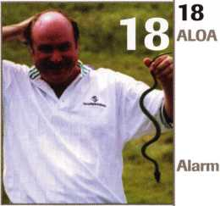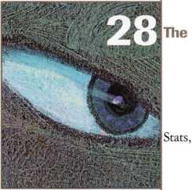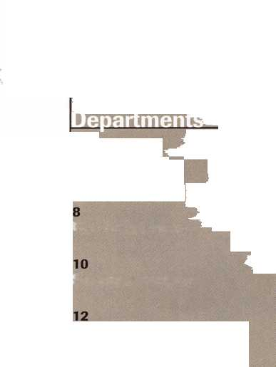

**PART NUMBER UPDATE**

With our recent change in warehousing, it has become  
necessary to change some of the part numbers you

are familiar with. We realize that this is somewhat of an

inconvenience to you. But, it is our intention that we will be  
better able to serve you by making these changes.

Please make note of the new part numbers. The old part numbers will reflect the new part numbers as "Use ######" in the description column in the STRATTEC 2000 Automotive Price List.

Please make the necessary adjustments in your company’s  
computer/record systems to reflect the new part numbers as listed below.

|  |  |  |  |  |  |
| --- | --- | --- | --- | --- | --- |
| Old Part # | New Part # | Description | Old Part # | New Part # | Description |
| 320291 | 322051 | GM Tumbler | 701651 | 701928 | GM, TGT, LSP |
| 320292 | 322052 | GM Tumbler | 701529 | 701797 | Chry, GB Latch |
| 320293 | 322053 | GM Tumbler | 702000 | 701855 | GM, Dr LSP |
| 320294 | 322054 | GM Tumbler | 702426 | 702433 | Chry, Dr LSP |
| 320295 | 322055 | GM Tumbler | 703396 | 704500 | GM, VATS Intgtr |
|  |  |  | 701234 | 701714 | Chry, Dr LSP |
| 594201 | 595511 | VATS Key | 380947 | 380703 | GM, GB Plug |
| 594202 | 595512 | VATS Key | 322117 | 323230 | GM, Sprg Rtnr |
| 594203 | 595513 | VATS Key |  |  |
| 594204 | 595514 | VATS Key | 609530 | 701398 | GM Ign Lock |
| 594205 | 595515 | VATS Key | 700172 | 701404 | GM Ign Lock |
| 594206 | 595516 | VATS Key | 700556 | 701406 | GM Ign Lock |
| 594207 | 595517 | VATS Key | 700580 | 702896 | GM Ign Lock |
| 594208 | 595518 | VATS Key | 700581 | 701400 | GM Ign Lock |
| 594209 | 595519 | VATS Key | 700582 | 701403 | GM Ign Lock |
| 594210 | 595520 | VATS Key | 700756 | 701407 | GM Ign Lock |
| 594211 | 595521 | VATS Key | 700914 | 701408 | GM Ign Lock |
| 594212 | 595522 | VATS Key | 701986 | 702619 | GM Ign Lock |
| 594213 | 595523 | VATS Key | 609780 | 609795 | AMC Ign Lock |
| 594214 | 595524 | VATS Key |  |  |
| 594215 | 595525 | VATS Key |  |  |  |

| STRATTEC

STRATTEC SECURITY CORPORATION Milwaukee, Wisconsin

©1999 STRATTEC SECURITY CORPORATION. All Rights Reserved.

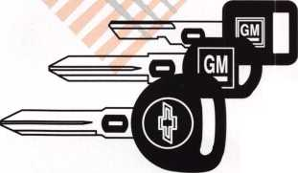

f£2 **rWi**

extend my subscription to Locksmith Ledger International

I | YE2 f S Please

J 3 YEARS (includes 36 issues, 3 FREE Annual Directory* issues)

USA $90.00

J 2 YEARS (includes 24 issues, 2 FREE Annual Directory* issues)

International (surface) $119.00

USA $64.00 Canada $93.00 International (air) $185.00

J 1 YEAR (includes 12 issues, 1 FREE Annual Directory* issue)

USA $41.00 Canada $52.00 International (air) $100.00

International (surface) $65.00

•Comprehensive guide to industry manufacturers, distributors, products and services.

**CARD INVALID UNLESS COMPLETE DATA IS GIVEN**

You must indicate your tocksmithing affiliation below:

1. Are you a locksmith or an individual involved in locksmithing? Qyes □no
2. **Your position is:** QOwner/Pres. Q3 Employee Q6 Student Q9 Other (specify)

**3 Business classification (check one only): a** QLocksmith Shop **b** □Hardware c □ Wholesaler/Distributor **d** Q Manufacturer **e** Q Security or Maintenance

1Q Consultant 3 Q industrial 5Q Government

2 Q Commercial 4 Q Institutional 6 □ Police **g** Q Architect/Specifier **z** Q Other (specify)

| 4. Are you involved in purchasing or influencing the purchase of locksmith products?

**□yes Qno**

Name:.

Company:. Address: _

City:.

. State:.

—Zip:_

Phone:.

.Fax: _

Payment (US FUNDS ONLY): □Money order □Charge Card □Check#:

Complete For Charge Orders Only: QviSA □ Master Card □American Express

Account# :Exp. Date:

Signature:

IM9

Send payment to: Locksmith Publishing Corp. • 850BusseHwy. • Park Ridge, IL 60068 • Phone:(847)692-5940 • Fax (847) 692-4604 • Website: [www.lpc.simon-net.com](http://www.lpc.simon-net.com)

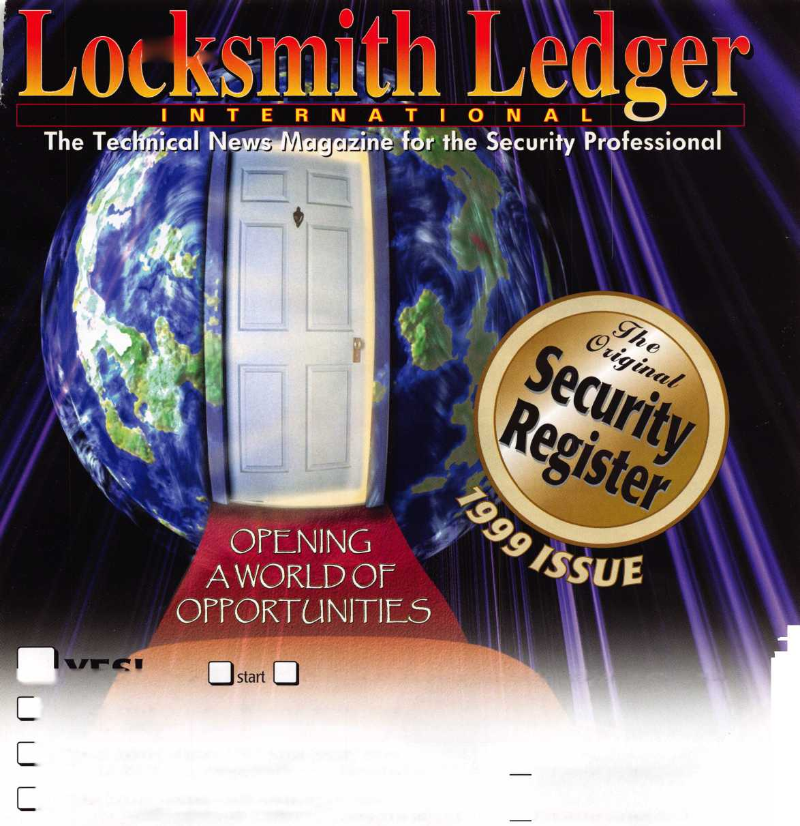

**Locksmiths..**

LA

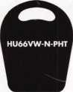

HU66VW-N-PHT

Audi

Porsche

Volkswagen

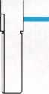

GM97-N-PHT[I

**_** T10HF54-N-PHT

Buick Park Avenue Chevy Venture Olds Silhouette Pontiac Montana Primary

Cadillac Catera

MAZ24-N-PHT

Mazda

Now you can duplicate electronic transponder keys without your customer bringing in their car or the original key. Store the codes in your database for future use.

It’s convenient, fast and profitable. It’s another JET innovation.

JET ETD - DUPLICATOR software for Windows 95/98 is conveniently provided on CD-ROM

***Jet***

JET HARDWARE MANUFACTURING CORP

800 HINSDALE STREET, BROOKLYN, NY

S **without**

rnrnm Tu 1 I

Nissan Maxima | mjj M

“ 1 **or (Hgtey**

For Windows 95/98

r

\

